Start- 4/23

End- 4/30

Investment : 1230 rupees

References:

<http://docs.ansible.com/>

**Ansible fundamentals:**

**Queries:?**

* State=present vs State=started vs state=installed?
* What is privilege escalation?

**What is Ansible?**

* Simple IT automation tool for deployments.
* Automating the repetitive tasks like sizing and creating new hosts/virtual machines and applying configuration on them, patching 100's of servers, migration, deploying applications, performance, security and compliance audits, provision VMs on a public cloud (Amazon), etc.
* All of these repetitive tasks involve writing 100 of commands on 100 of servers while maintaining the right sequence of events in system reboots in between and whatnot.

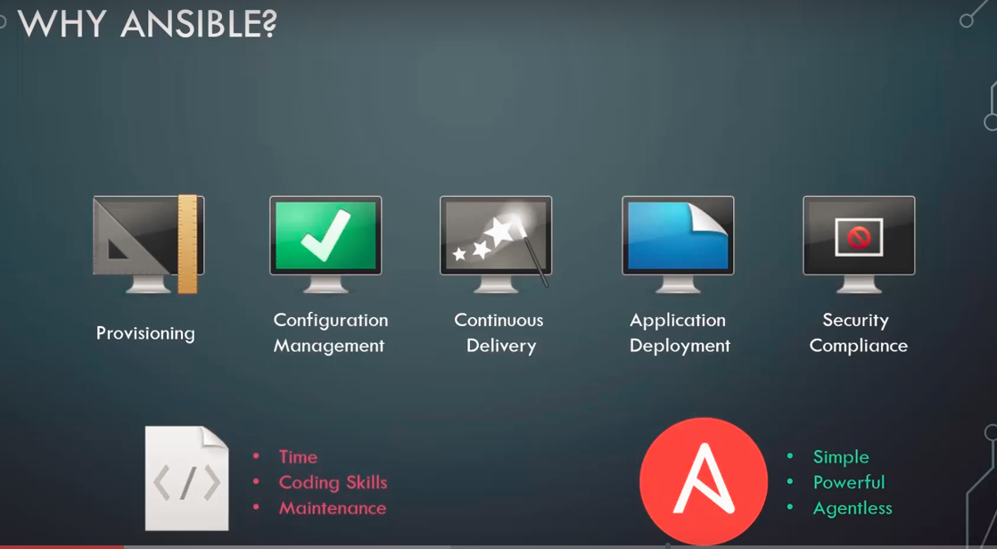

Simple use case of using ansible:

1. Suppose we have a number of hosts and a database server in our environment
2. We want to restart them in a particular order.
3. We want to power down webserver first followed by database servers and then powerup the database servers and followed by webservers.
4. We can write simple Ansible playbooks in a matter of minutes to achieve this task.

Benefits of Ansible:



Note:

1. Ansible Controllers can only be linux. Windows can be used as target servers.
2. We can practice ansible in local using docker.
3. We don't need to install ansible in the target funtion.

YAML:

* All ansible playbooks are text files/Configuration files that are written a particular files known as YAML

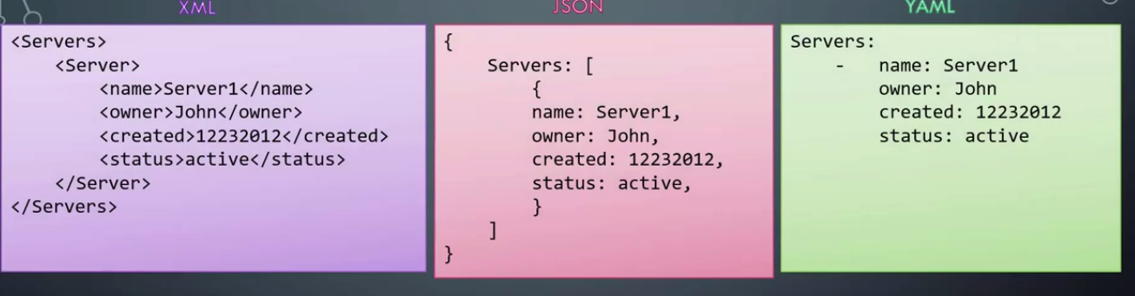

* A yaml file is used to represent configuration data in Ansible.
* Data can be represented as key-value pairs, list or dictionaries as following:

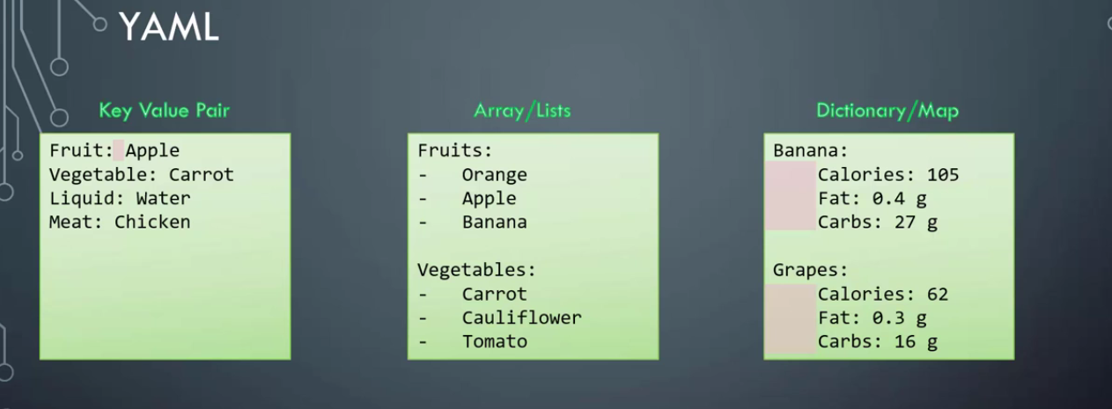

* For dictionaries/map we need to have constant number of spaces in order to categorize the items correctly.
* This following inconsistent spacing will give a incorrect or inconsistent results:

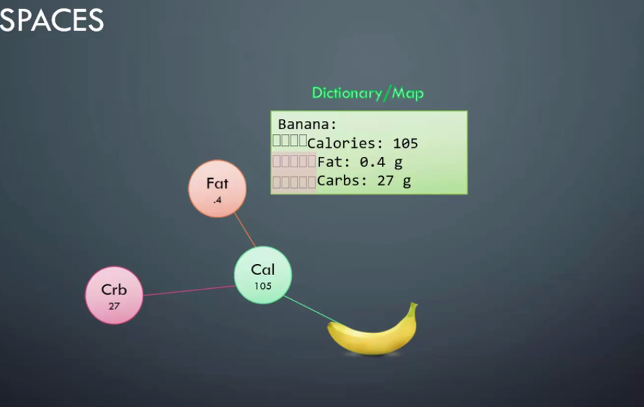

* List of dictionaries:

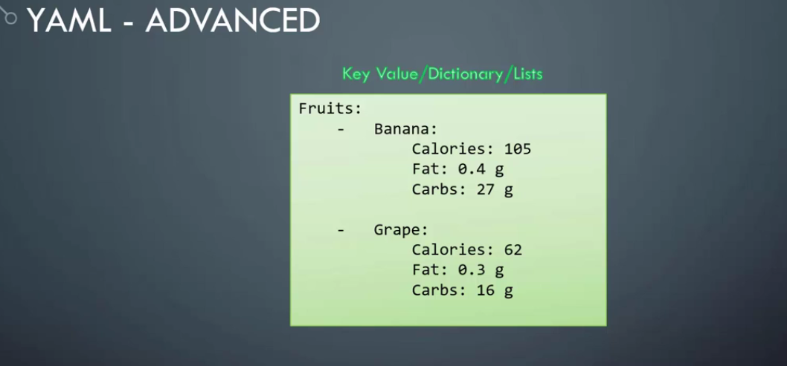

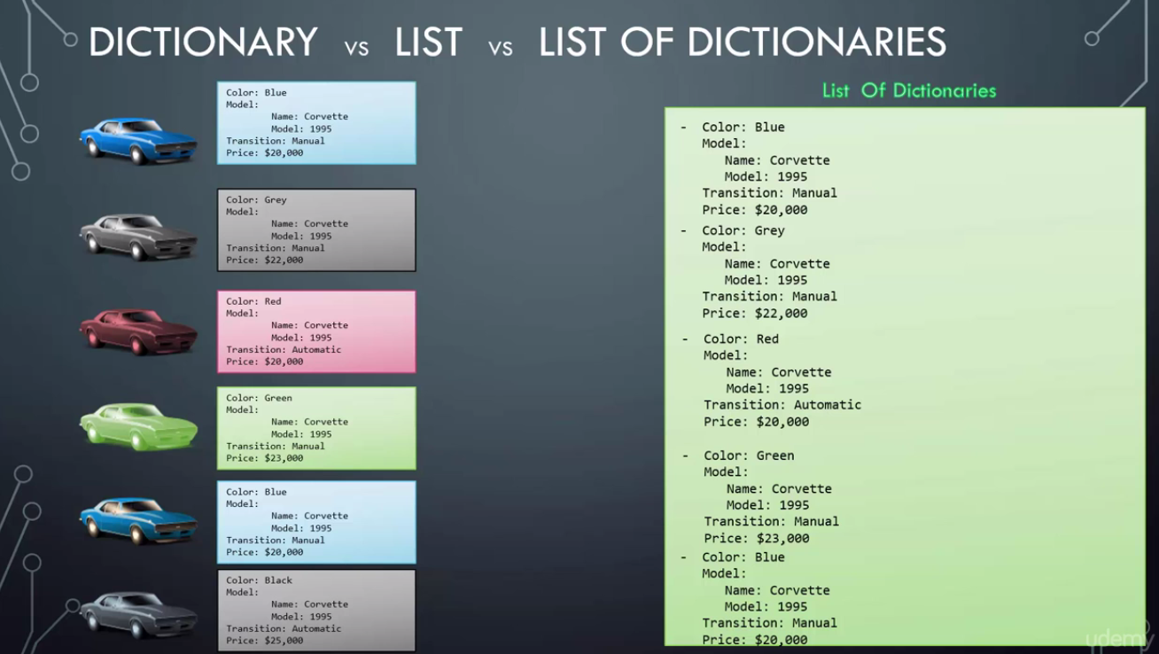

YAML Notes:

* Dictionaries are unordered. That is, two dictionaries with same properties mentioned in different order are same as long as the properties and their values match.

* In list, the orders matter. If the order is not same, then the lists are not same.

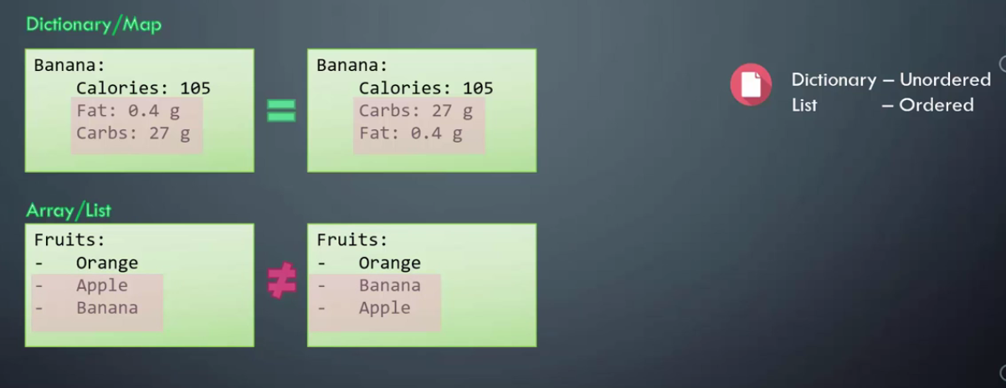

* Line beginning with # is ignored so we can use it to add comments.

**- Setting Ansible Environment:**

Ansible Inventory:

- Ansible can work with one or more servers in our environment.

-for this ansible needs to establish a connection with those servers.

-This connection is established using ssh for linux and powershell remoting for windows.

-this makes ansible agentless, that is we don't have to install any software on the target machine to make it work with ansible. Simple SSH connectivity would be enough.

* Inventory files Stores information about the target system.
* If no inventory files are created then ansible uses the default inventory files located at etc/ansible/hosts
* An inventory is like an ini file type that simply the number of servers listed one after the other.
* We can also group the servers together by providing the group name is a square brackets.
* We can have multiple groups defined in a single inventory file.

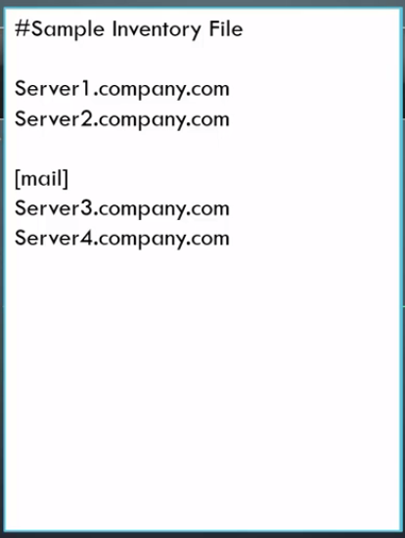

* We can define servers into different groups based on the usage, like may have database servers or webservers.

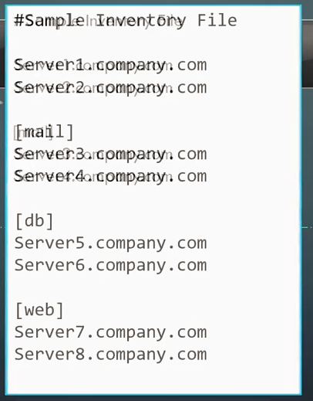

* We can define servers names with fqdn with alias name in ansible inventory file.
* Use this approach we can know the purpose of the server using the alias

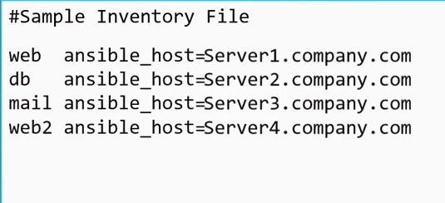

* Above, we have provided hosts for fqdn

Important parameters used in inventory file:

1. Ansible_host:

* Just looking that server name or its fqdn does not tell us for what purpose this server is created.
* So we can provide an alias name to the server and assign its fqdn to 'ansible_host' parameter.
* Ansible_host is an inventory parameter to specify the fqdn or ip address of the server.

1. Ansible_connection:

* Defines how ansible connects to the target server.
* This can ssh for linux and winrm connection to a windows host.
* This also defines if the target machine we are connecting to is a linux or windows host.
* We can also set it to localhost to work with local host if we don’t have multiple servers to play around with.

1. Ansible_port:

* Defines with port to connect to.
* By default its port 22 for ssh.

1. Ansible_user:

* Defines the users used to make the remote connection.
* By default this is set to root for linux machines and we can use 'ansible-user' parameter to change it.

1. Ansible_ssh_pass:

* Defines ssh password for linux.
* We can use ansible_vault to securely store the password or anyother secure data.
* Ansible-value uses encryption to store secure data.

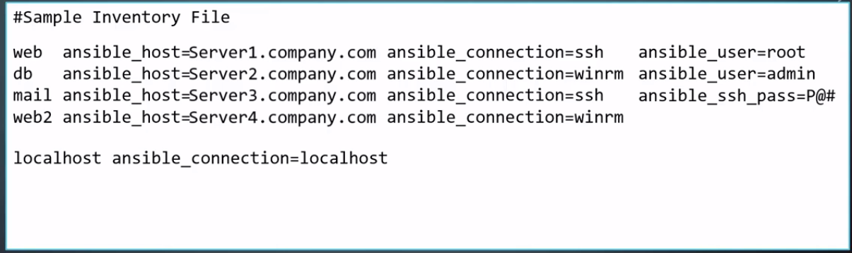

**Anisble Playbooks:**

* Ansible orchestration language
* Here we provide instructions to ansible to do things that we want it to do.
* For example, we can run some command some servers in some sequence and restarting them in a particular order.

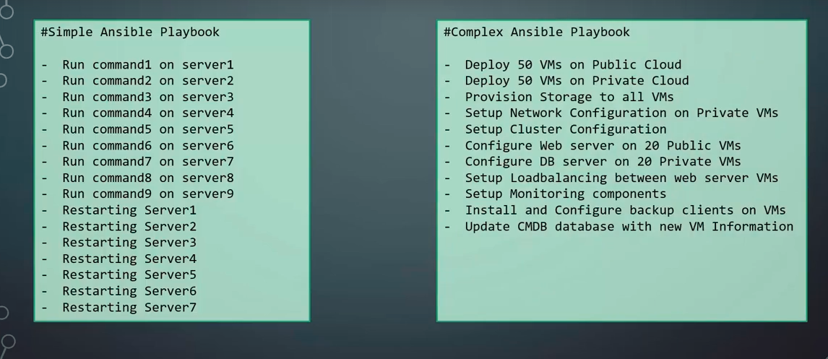

* All playbooks are written in yaml format.
* A Playbook is single yaml file contains plays - set of activities/tasks to be run on group of hosts.
* Examples of tasks - executing a command or script on host, installing a package on host, perform shutdown or restart on a host.
* A play defines the action we can to perform on a particular host.
* Sample Playbook format:

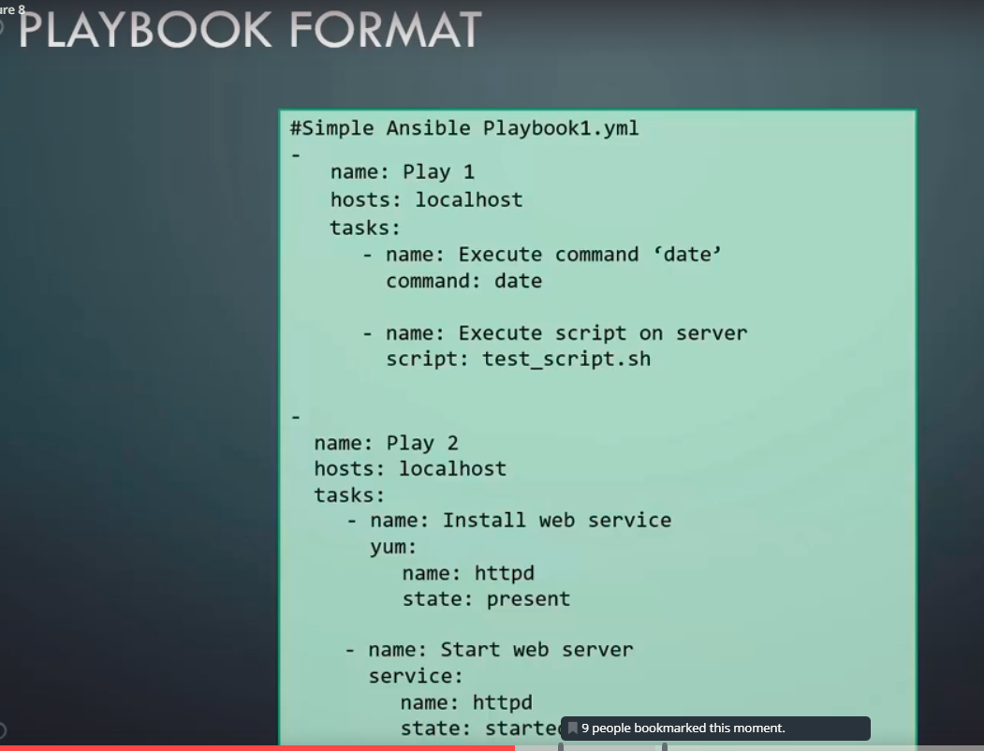

* The host defined in the playbook must be defined in the inventory file.

**Ansible Modules:**

* The different actions run by tasks are called modules - 'command', 'script', 'yum', 'service'.
* Command modules simply run the commands on the specified server.
* ansible-playbook <playbook-file-name> : This command can be used to run the ansible command.

* Ansible modules are categorized based on their functionality:

1. System module:

* Actions to be performed on a system level. Like modifying the users, groups, IP Tables, mounting operations, etc.

1. Command modules:

* To execute command or scripts on a host.

1. File:

* Work with files.

1. Database:

* To work with different databases like adding/removing databases, modifying configurations.

1. Cloud:

* Contains modules for different cloud provider, like amazon, google
* We can perform tasks like creating/destroying instances, performing configuration changes, networking and security.

1. Windows module:

* To help ansible in windows environment.

Ansible Variables:

* Stores values that varies with each host.
* We can define variables in both inventory files and in playbooks.

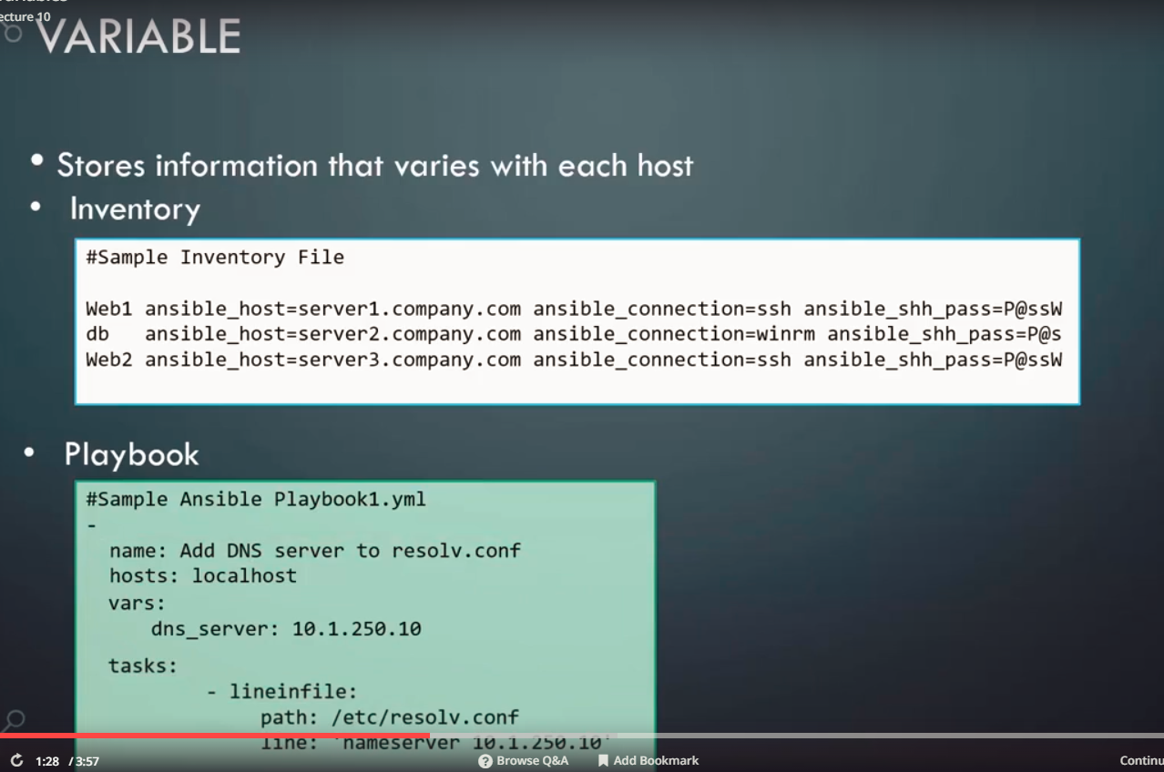

* We can use the variables by enclosing them in {{ }}

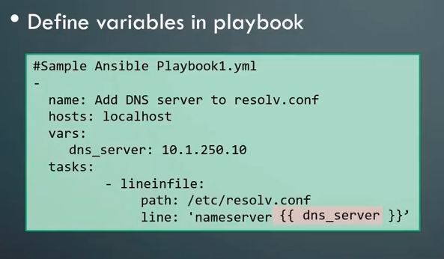

* A common way is to declare the variables in the inventory file and then use them as {{ }} in the playbooks so that any changes can be restricted to inventory files only :

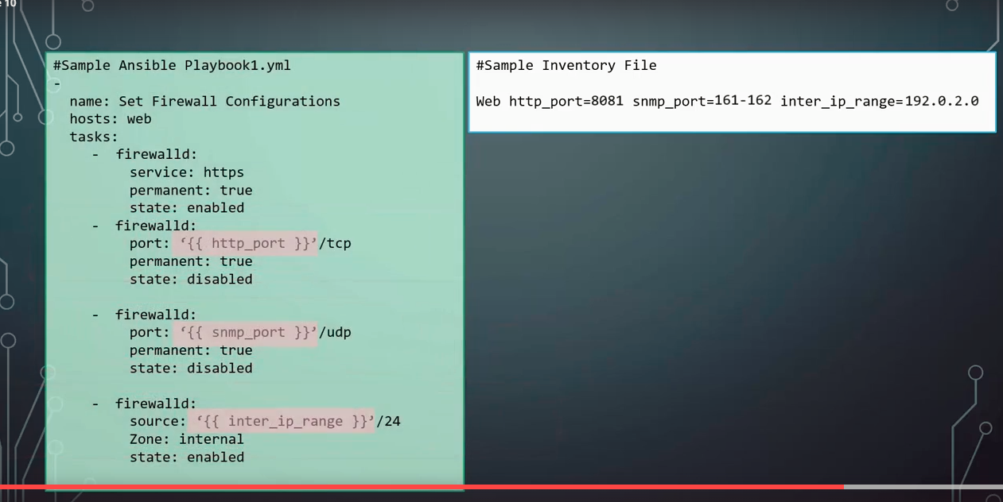

* Another way to use variables is to add them to a file in the name of the host.

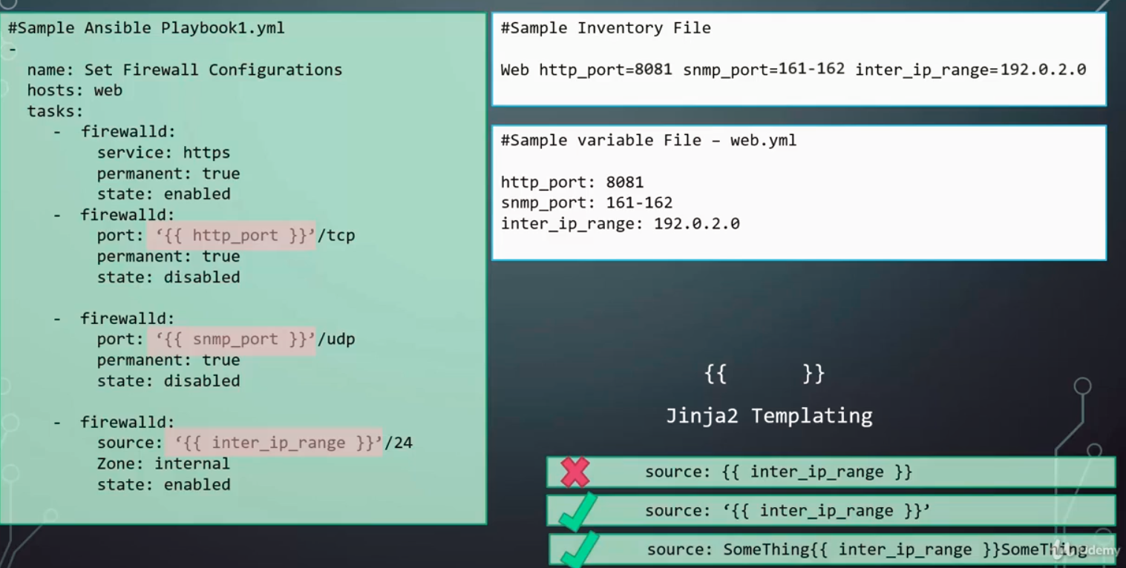

* Use quotes before the jinja template if it’s the first word, if its just used between a word, then don't use quotes. (see above screenshot)

Conditionals:

* We add conditions when we are executing the ansible playbooks.
* We can use 'when' with 'or' and 'and' statements to use conditionals in ansible
* Note: We should use '==' for comparison along with 'when'.

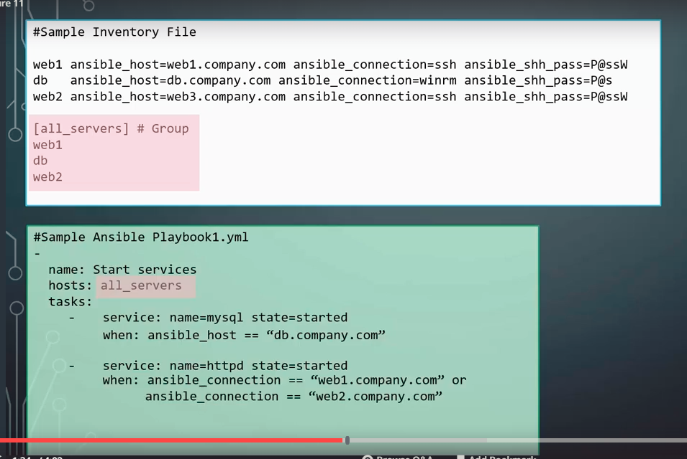

* We can also capture the output of a module when its executed and add validations on the output.
* Register directive can be used to store the output of a module (example command_output).

* Here we are capturing the output of 'command_output':
* Below, we used the register to store the command output and use it to send email if the command execution was not successful.

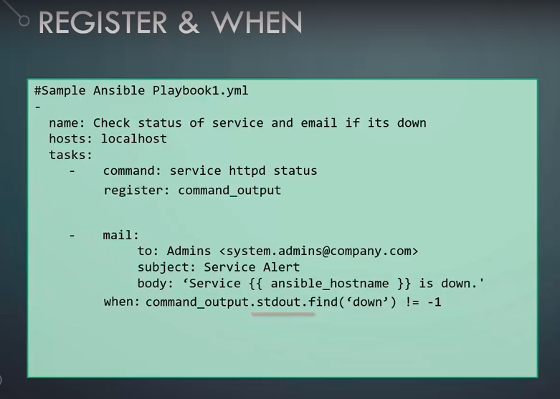

**Loops:**

* We can create a single task to loop over modules in-order to perform a repetitive task.
* 'With-item' looping directive is used to execute the same task multiple times.
* When using 'with-item' we can replace the values using the {{ item }} variable.
* 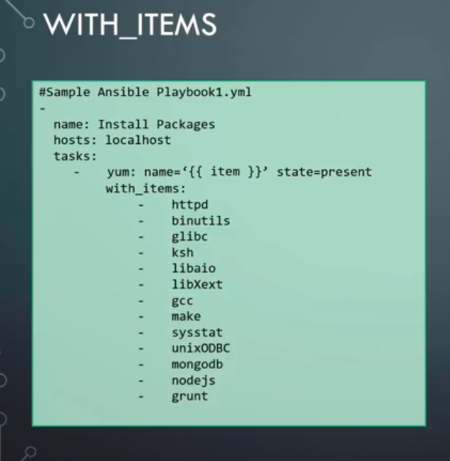

Ansible Includes Roles:

* Ansible roles helps us to write cleaner ansible code.
* We can us the 'include' keyword to use one playbook into another file. (thus modularizing our ansible code)
* The idea to reduce a long playbook into small files the define specific tasks or logic and then add include those playbooks in a master file.
* 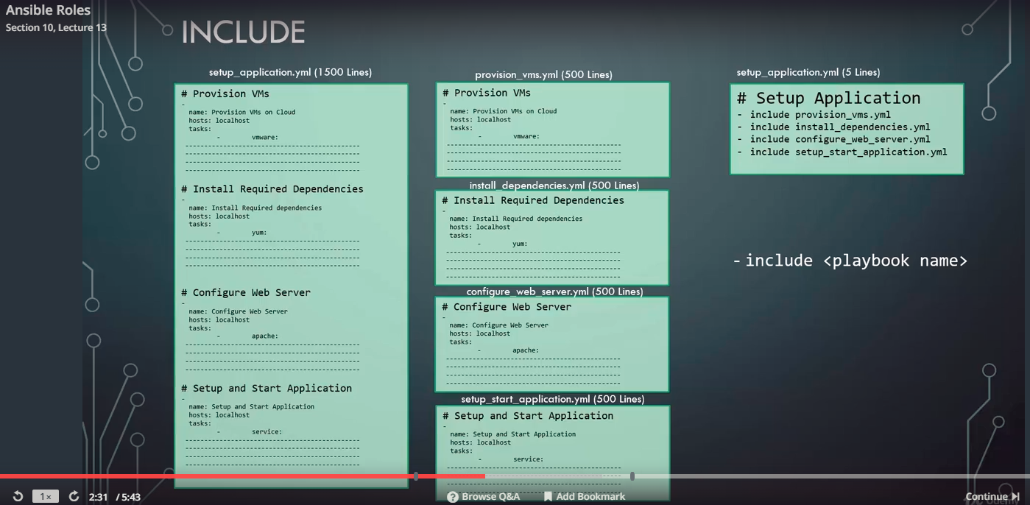

* We can also create 'tasks' in separate files and include them to a different file in order to use.

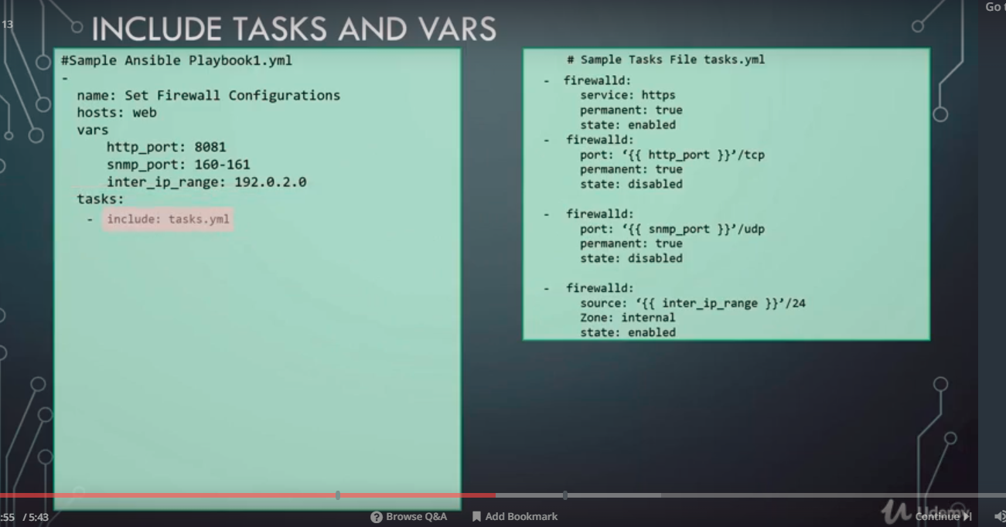

* We can also have the variables in a different file and then use them in a different file
* In case of variables, we don't use 'include', we use ' vars_files' keyword.

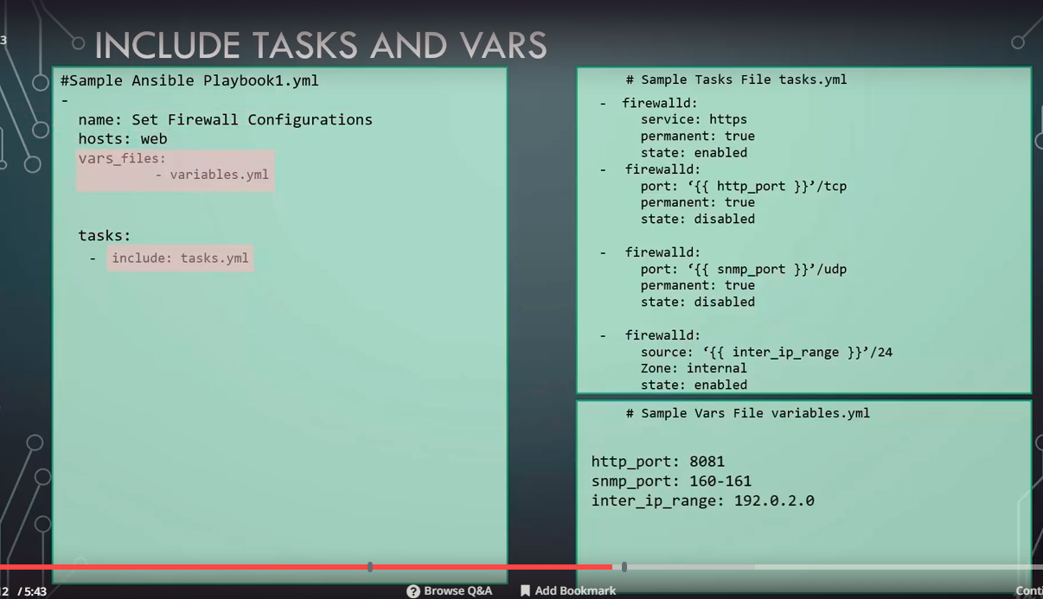

* Ansible roles defines a standard on how files and folders should be structured in your project.
* Using a predefined standard helps us to use variable, tasks etc without any include. What we can do is move parts of playbook in different (pre-defined) folders, for example, we can move the variables in the 'vars' folder and the 'tasks' in the 'tasks' folder. And in the master playbook, we can simply assign the roles to the server.
* One of the advantages of the 'roles' is that we don't need to import the variables and tasks using the include statement
* 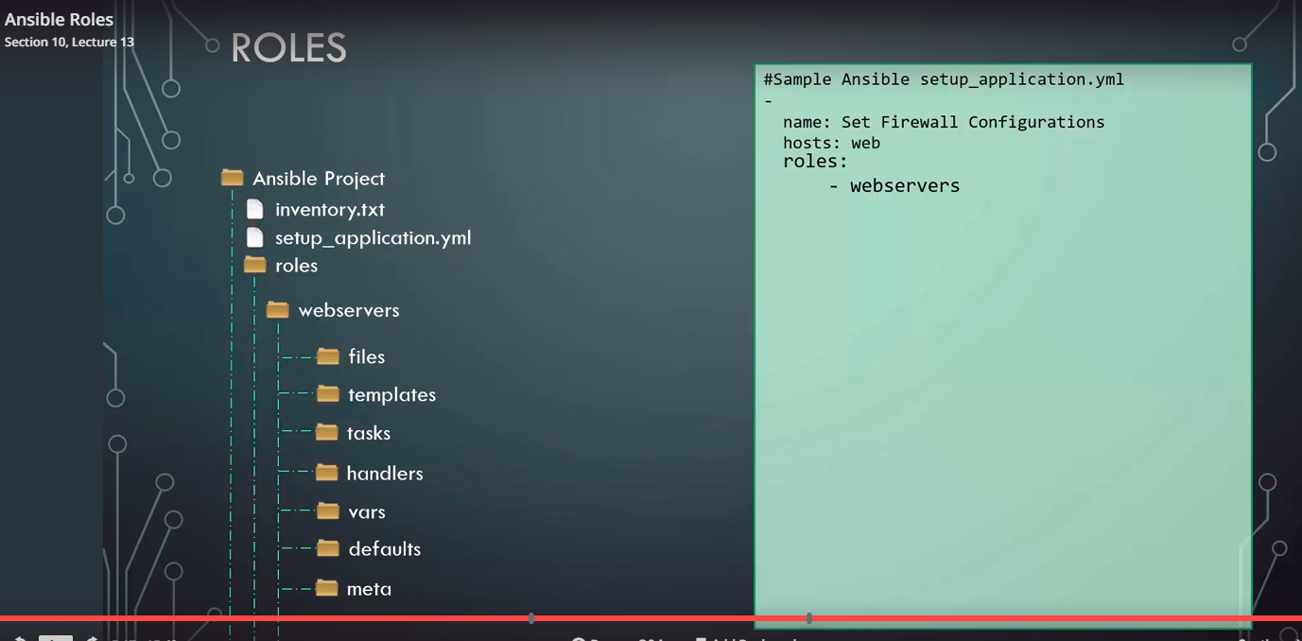

* Above, we have just provided the roles (webserver) to the ansible playbook, and it automatically takes all the variables from the 'var' folder, all the tasks from the 'tasks' folder and likewise.

Advanced Topics:

* Preparing Windows:

QuerieS:

1. Ansible is agentless?:

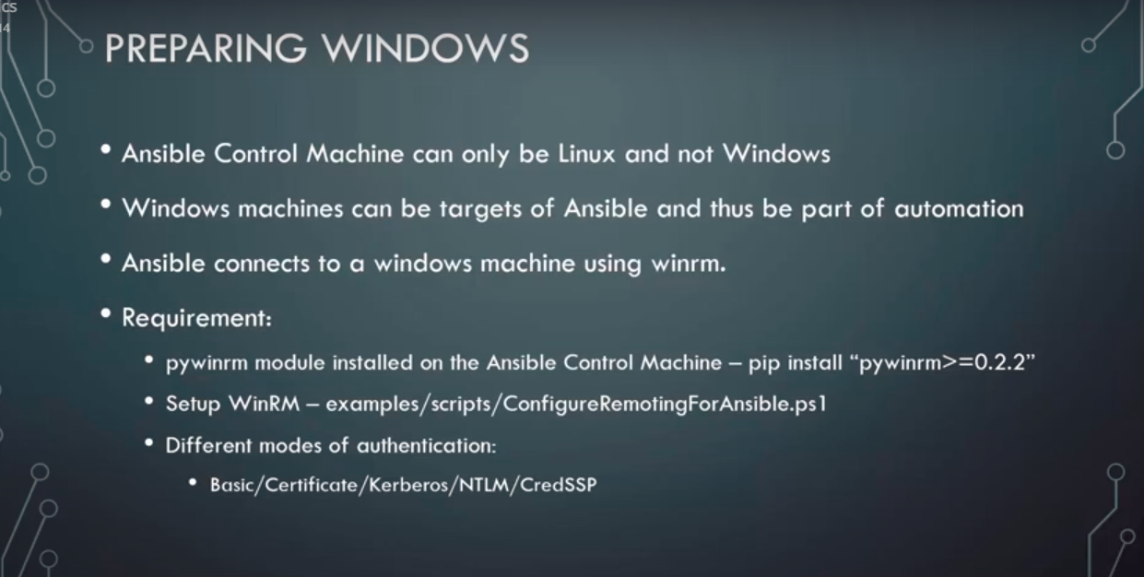

1. Ansible Galaxy : to store and download ansible roles.
2. Patterns: We can specify patterns when using hostnames
3. Dynamic inventory - Rather than having a static inventory.txt file, we can also create a dynamic .py file to create inventories:

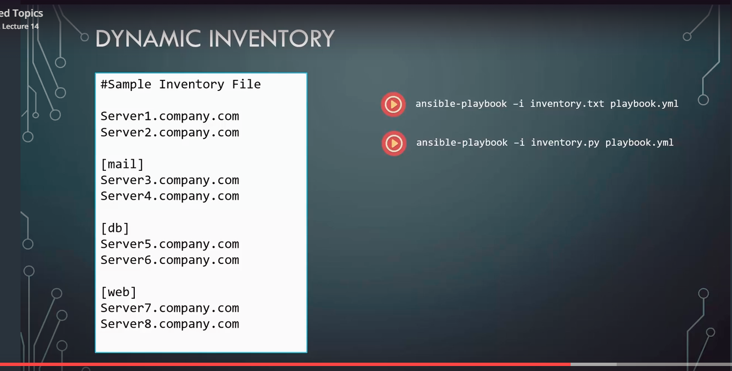

1. Custom Modules:

* Apart from the built-in modules in ansible, we can also create custom modules using python language and add them to our 'modules' directory.

--------------------------------------------------------------------------------------------------------------------------------------------

**ANSIBLE ADVANCED:**

* Ansible setup with docker:

* Sample Ansible playbook for a simple application:

-

name: Deploy a web application

hosts: db_and_web_server

vars:

db_name: employee_db

db_user: db_user

db_password: Passw0rd

tasks:

- name: Install dependencies

apt: name={{ item }} state=installed

with_items:

- python

- python-setuptools

- python-dev

- build-essential

- python-pip

- python-mysqldb

- name: Install MySQL database

apt:

name: "{{ item }}"

state: installed

with_items:

- mysql-server

- mysql-client

- name: Start Mysql Service

service:

name: mysql

state: started

enabled: yes

- name: Create Application Database

mysql_db: name={{ db_name }} state=present

- name: Create Application DB User

mysql_user: name={{ db_user }} password={{ db_password }} priv='*.*:ALL' host='%' state='present'

- name: Install Python Flask dependencies

pip:

name: '{{ item }}'

state: present

with_items:

- flask

- flask-mysql

- name: Copy web-server code

copy: src=app.py dest=/opt/app.py

- name: Start web-application

shell: FLASK_APP=/opt/app.py nohup flask run --host=0.0.0.0 &

* **Variable File Separation:**
* It's better to define the variables in a separate file for the server, rather than in the inventory file.
* To do this:

1. Create 'host_vars' directory along with the playbook file. (Strictly name the folder with same name 'host_vars')
2. Create a yml file with the same name as the server. (because ansible will automatically take the server name from the file name). We need to create a new yaml file for each server.
3. Move variables and values from the inventory file into this new file. (remove equals sign and change it to a semicolon with face, because the new file is yml format
4. Similarly for group variables we need to create a 'group_vars' folder.

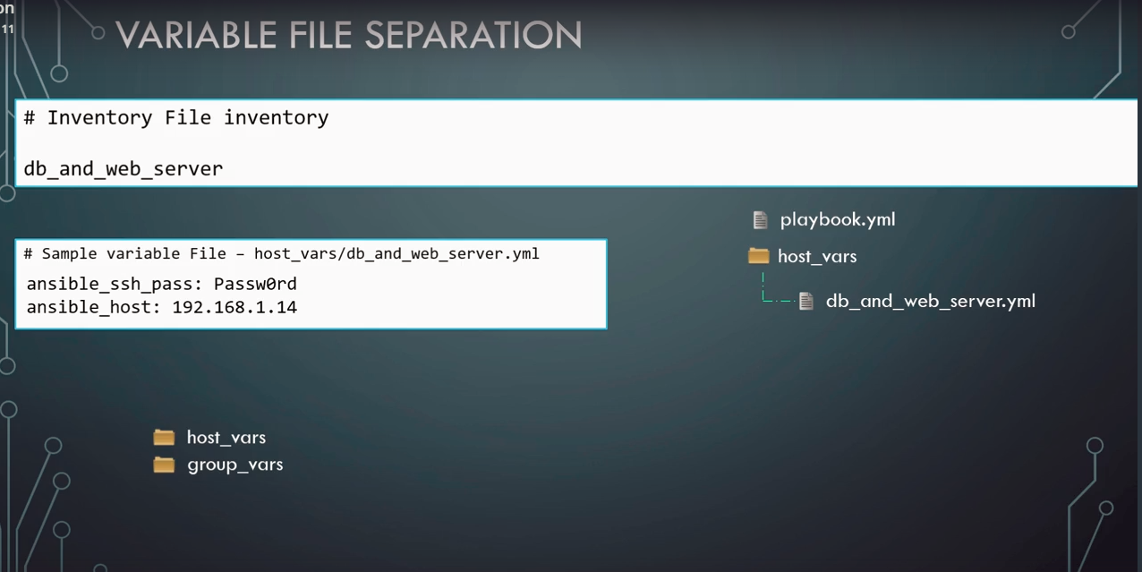

* **Includes:**
* Suppose we have two kinds of tasks in a playbook - Install database and Install server.
* So we can move these tasks to different 'yaml' files under 'tasks' folder.
* Then we can use the 'include' statement to include these tasks form the external files.

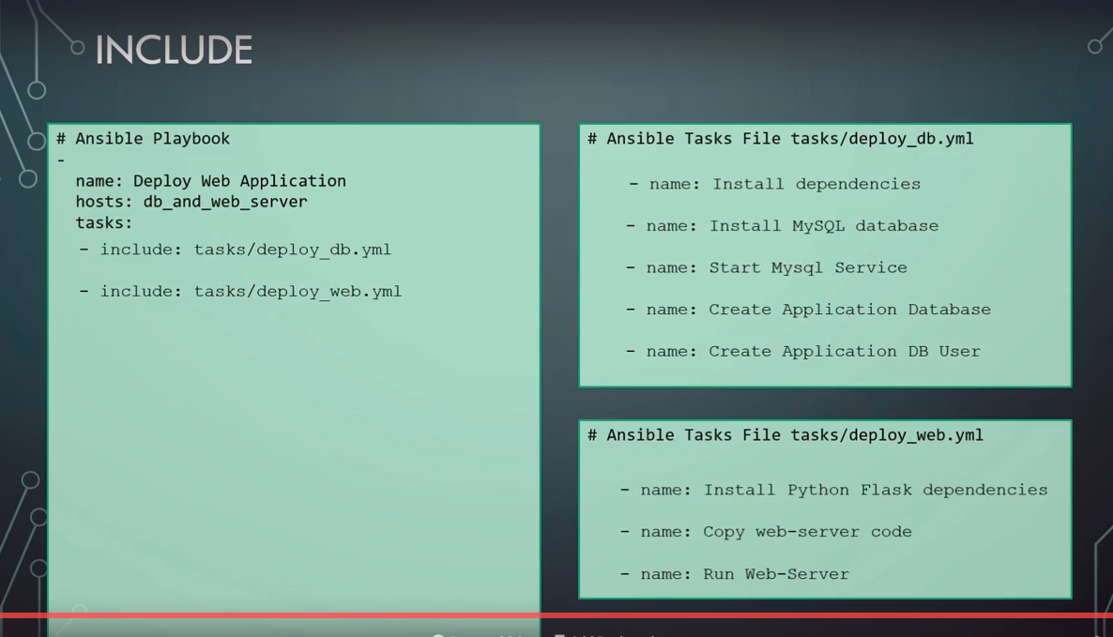

**Roles:**

* Roles are the recommended way for developing a project in ansible.
* ansible -galaxy init <role_name> command is used to create a new role. It will create the folder structure for us automatically.
* We don’t need to use ansible-galaxy init command. We can also manually create the required folder structure.
* Roles help to

1. organize the projects in standard structure.

2. reuse roles within the project

3.share our work through github or ansible galaxy

* We have to simply create a role and assign it to the webserver.
* Doing this, ansible will automatically load the tasks from the main.yml file in 'tasks' folder, variables from the 'vars' folder and defaults from the defaults folder and makes them available for the playbook.
* We don’t have to use any include command in the playbook if we are using roles.
* We can share and reuse these roles with ansible galaxy.
* We can check for any existing role in ansible galaxy before creating one of our own.
* 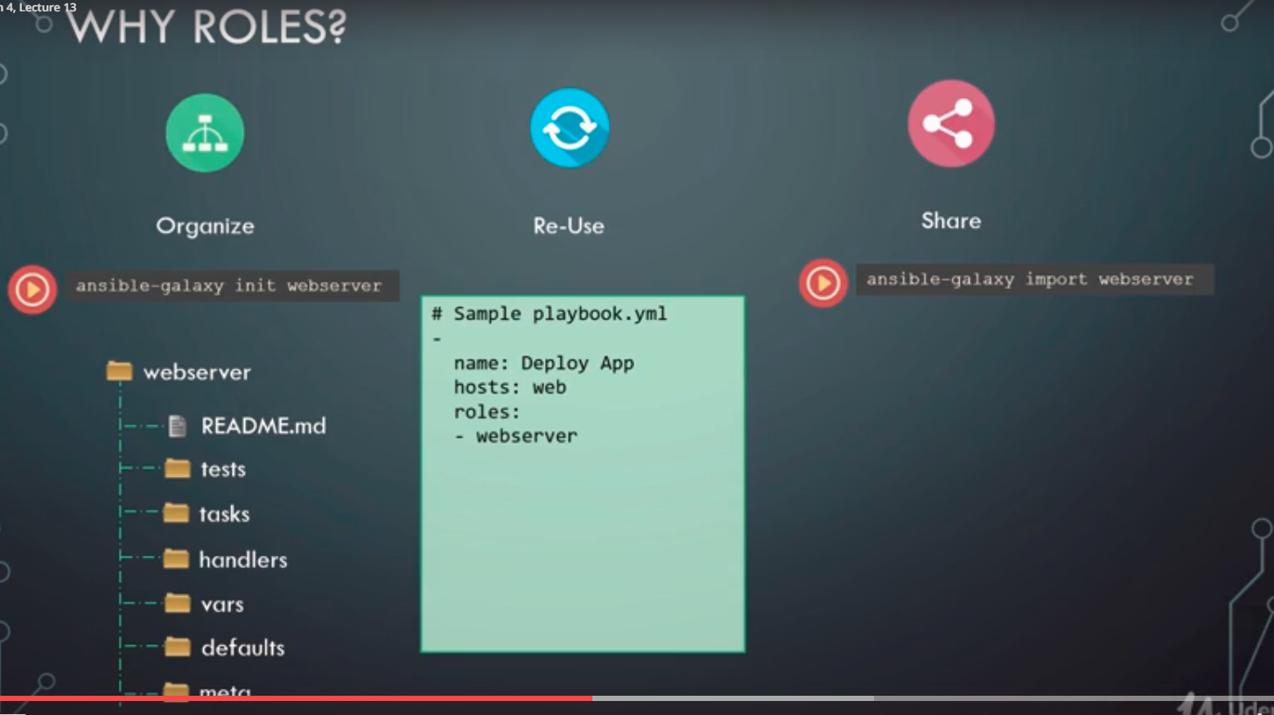

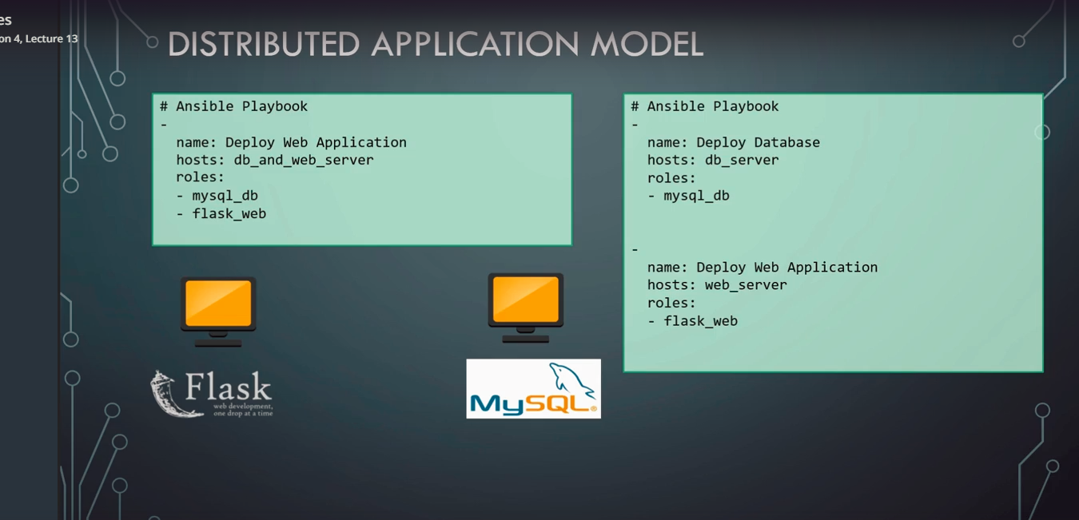

* Roles can be defined with 'roles' key and each role is added as a list.
* The order in which we add the roles is important.

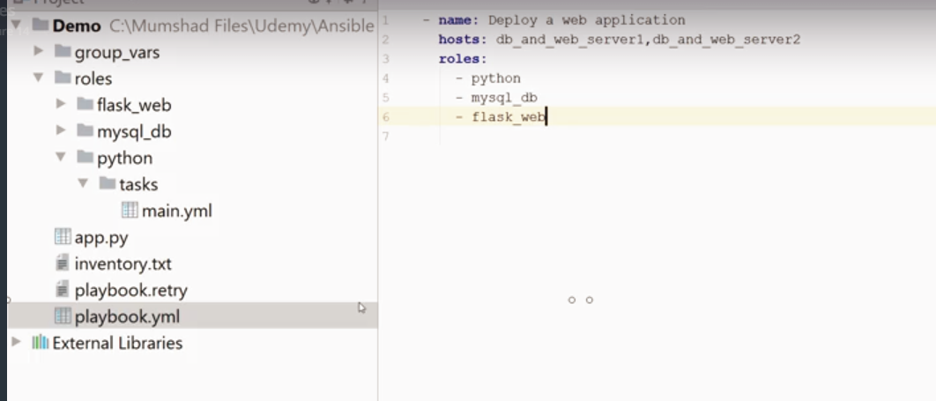

* We can upload our projects to ansible galaxy for others to use.
* Standard naming convention for creating a role in ansible galaxy is 'ansible-role-<role_name>'.
* To add our local project to ansible galaxy:

1. Create a git hub project.
2. Add your role to the git hub.
3. Go to 'My Roles' in ansible-galaxy
4. Refresh to fetch the latest ansible roles in my git hub account.
5. Import the project.

**Asynchronous Action:**

* Ansible establishes connection with the target server over ssh
* This ssh connection remains alive through out the execution of a task in a playbook.
* We might have to achieve following:

1. Run a long process task that exceeds the ssh timeout.
2. Run multiple processes at once and then check on them later.
3. Run multiple process and don't bother the check their status.

* For all these above use cases we can use 'asynchronous action'.

For example,

Suppose we want to do some health checks on a webserver, say we run a script that checks if the server is running for 5 minutes without any issues.

This script takes 5 minutes to complete execution and we don't want ansible to hold the ssh session alive untill the script finishes execution.

So we tell ansible that this is a asynchronous tasks and check it after , say , 5 minutes.

* We use 'async' directive to specify and asynchronous tasks.
* Ansible by default checks the status of the script every 10 seconds.
* To change that we can use the 'poll' directive.
* Using poll, instead waiting for the entire duration of the 'async' time, ansible will check after time interval specified in the 'poll' directive.

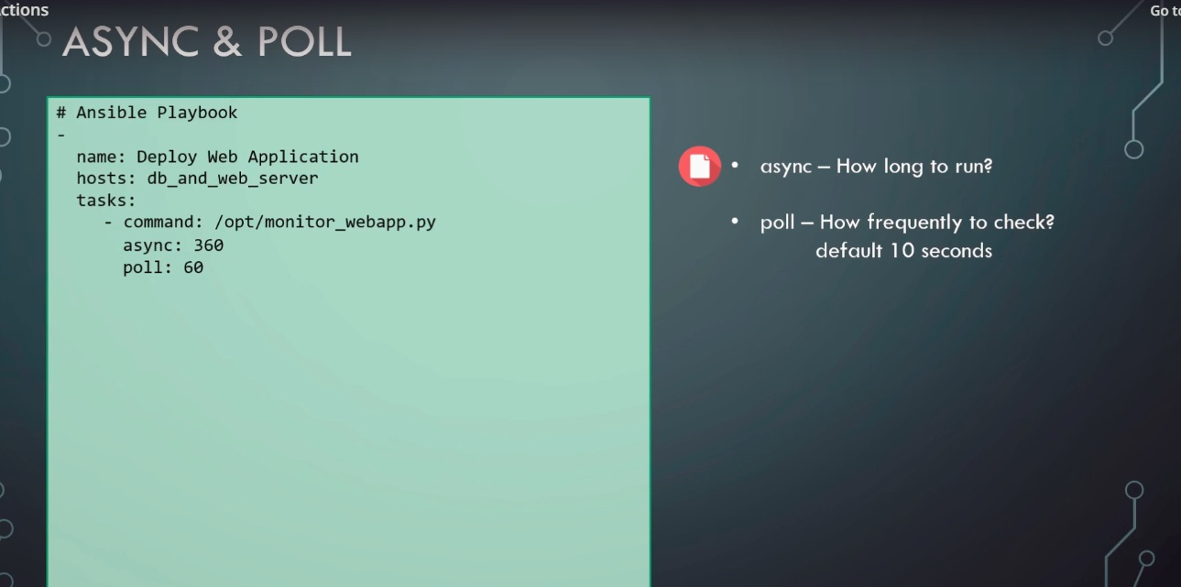

* Important: asynchronous does not mean that ansible will start a task and move the next one without completing the first one.

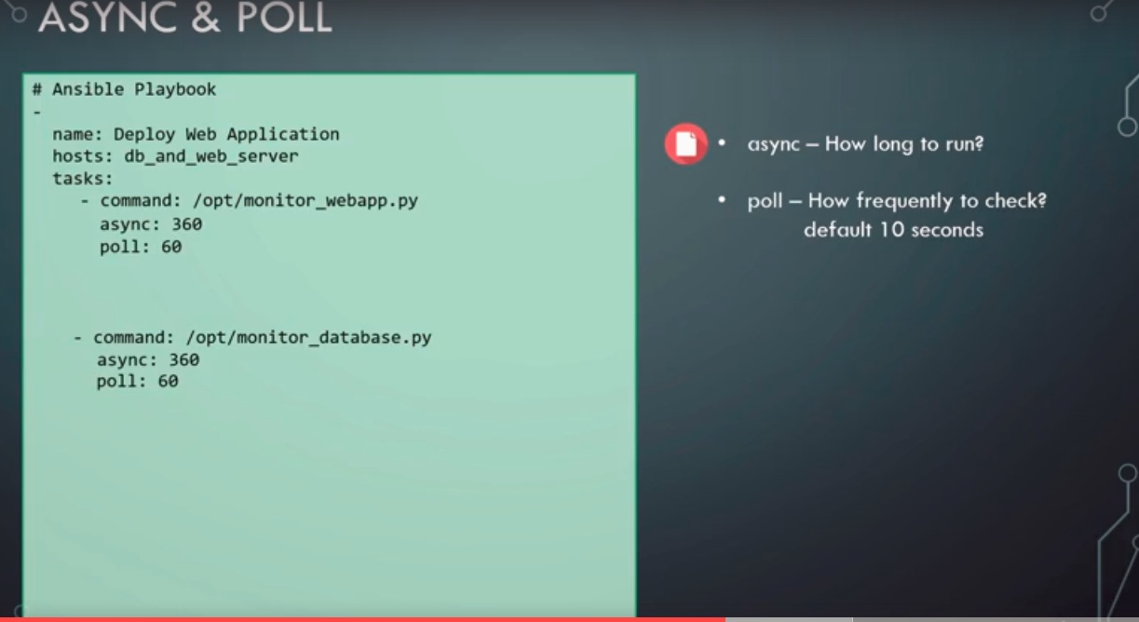

* In the above example, ansible will start the first task to run the script, wait for it to complete, ( 6 minutes) and then start with the next task.
* This is not a good approach as time is wasted over here. We could improve this by running both of them in parallel.
* This could be achieved by setting the poll value to zero, this asking ansible not to wait their polling a task, but to move to next task immediately.

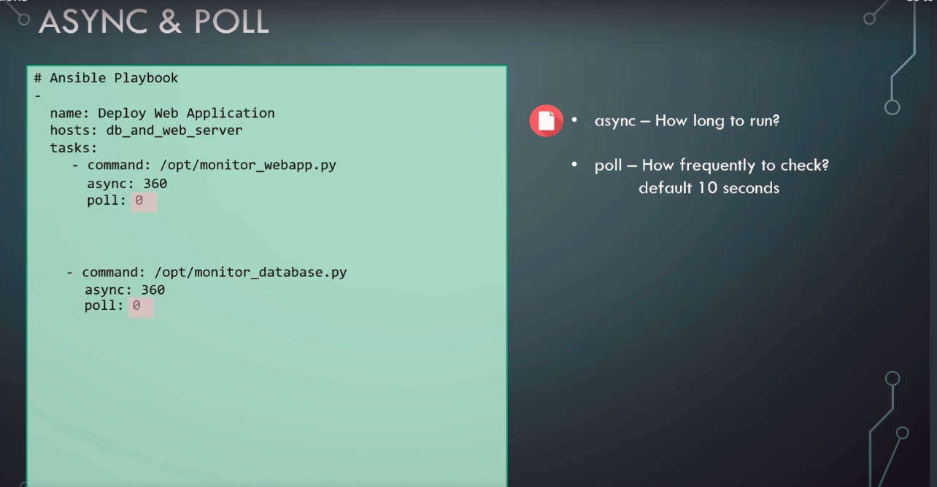

* Making poll value zero, we won't be able to check the task completion as ansible will exit after starting both the tasks. This is a 'fire and forget' approach.
* To avoid this, we need to:

1. Register the results of both the task.
2. Create a new task to check the status of the task using 'async_status' module.

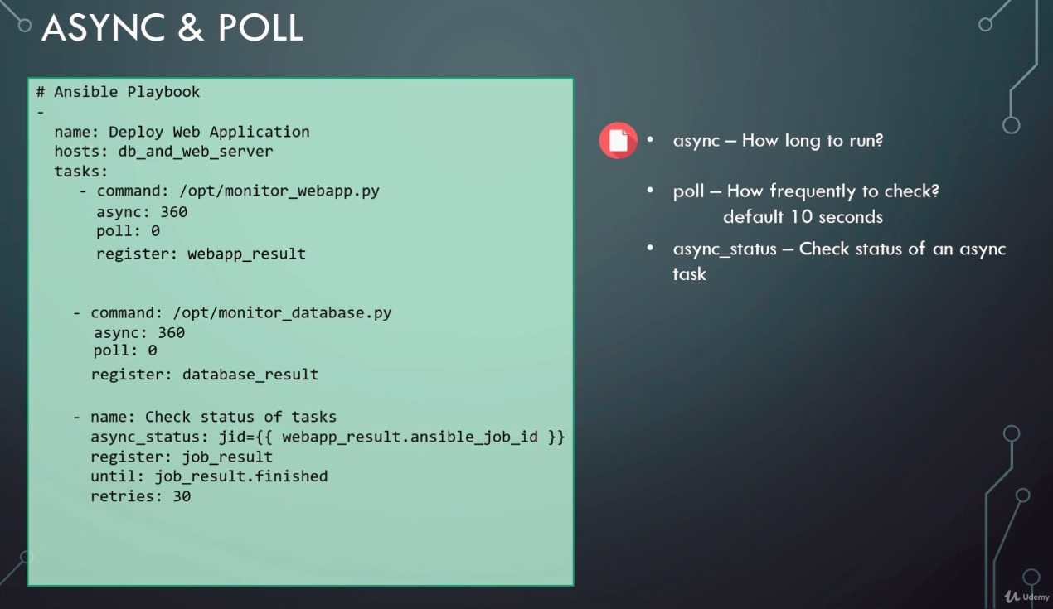

Note: All modules don't support async. So we need to check that before using asynch.

**STRATEGY:**

* Strategy defines how a playbook is executed in ansible.
* It’s the flow the tasks in ansible.
* In case of a single server, ansible executes eact task against the server until all of them are complete.

1. Linear Strategy:

* By default, ansible has a Linear strategy, that is, in case of multiple servers, ansible runs one task in each server in parallel and waits for this task to be completed in all the servers, before starting the next task in all the servers (again in parallel).
* 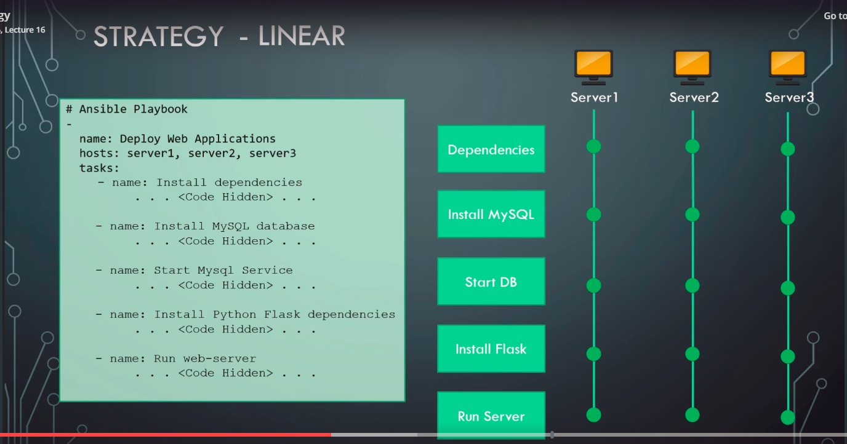

1. Free Strategy:

* Here, tasks will be run independently on each server, without bothering about the status of tasks in the other servers.
* To use this, add 'strategy: free' in the play.

1. Batch Strategy:

* Suppose we have 5 servers and we want ansible to execute 3 at a time.
* This is where batch strategy can be used. Its based on the linear strategy but we control the number of servers we can to execute at a given time.
* We can use 'serial' directive to specify the number of servers we want to run.
* 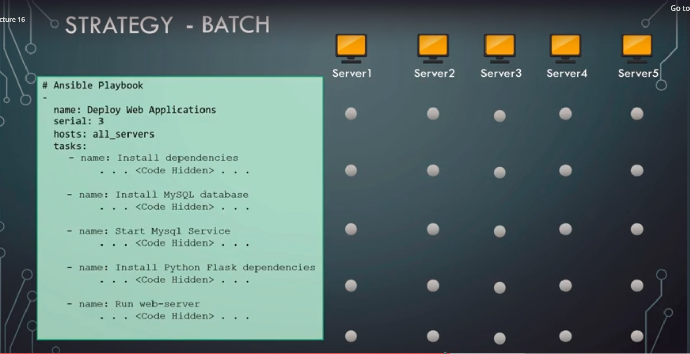

* We can also specify serial value in %.
* The serial directive also has some advanced use cases. For example, we can run the play against 2 servers first, then 3 in the next round and then last 5 together by providing an array as an input to the serial directive This is really useful for 'rolling updates' .

1. Forks:

* Ansible uses parallel processes called forks to communicate with remote hosts.
* By default, ansible can create 5 forks at a time. So if we have around 100 servers in playbook, ansible won't run all of the in parallel.

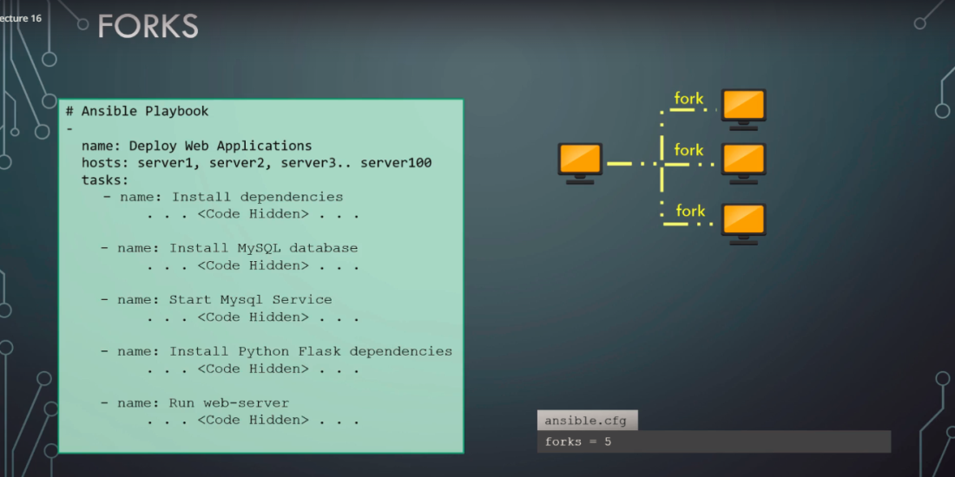

* Default value of ansible fork is 5 in the ansible.cfg file. We can increase this value based on the sufficient cpu and network bandwidth

**ERROR HANDLING**

1. Single server scenario :

* If the play fails at a particular task, it will simply exit.

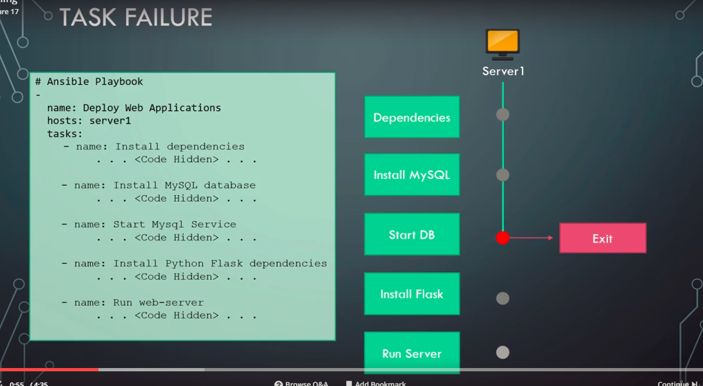

1. Multiple server scenario:

* If the play fails in one of the servers, then ansible removes that server from the list and continues with the play in other health servers.
* Ansible will attempt to complete as many servers as possible. This is the default behavior.

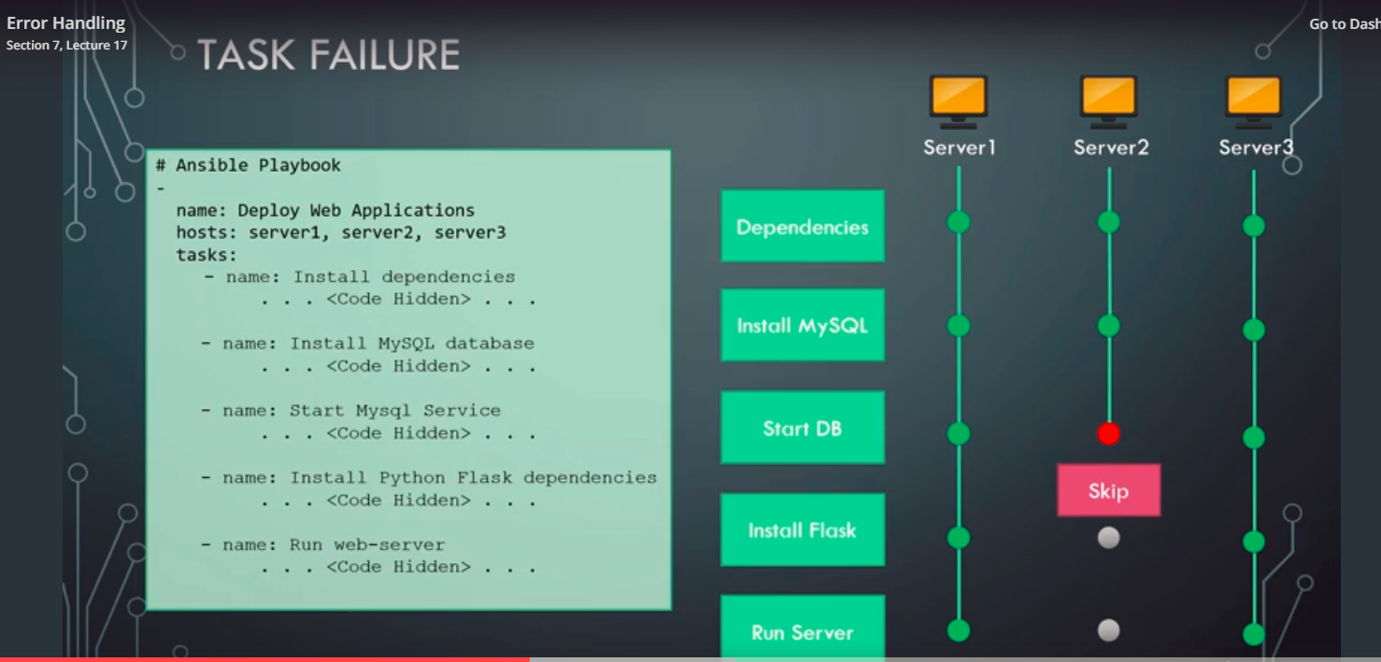

* To change this default behavior, we can add a directive - **'any_errors_fatal: true' on the play**. This will stop the play on all the servers if there is an error in one of the servers.

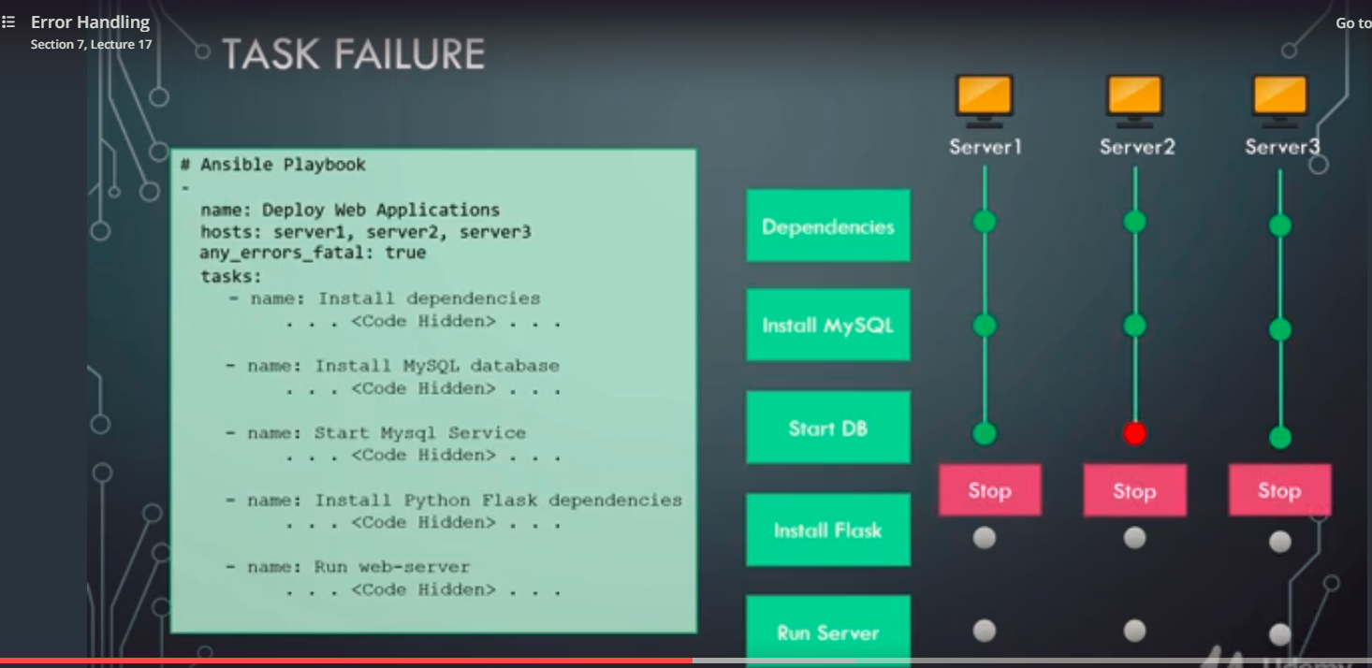

1. Ignore errors:

* Sometimes a task is not very critical and we don't care if it fails.
* In such case, we can use **'ignore_errors: yes' directive on the task**
* With this directive, the playbook execution will not stop on error, it will simply continue on error.

1. Failed_when:

* We can fail the playbook by adding specific conditions.
* 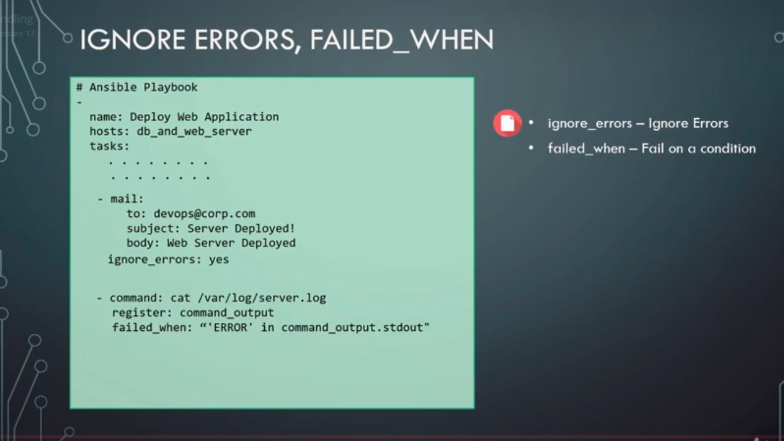

* The above example, checks if there is any error in the 'server.log' file and fails.

**JINJA 2 TEMPLATING:**

* Templating : Process of creating dynamic content or expressions.
* Every expression if ansible is first evaluated as a template.
* Debug module is used to store print something on the screen.
* Some jinja 2 examples:

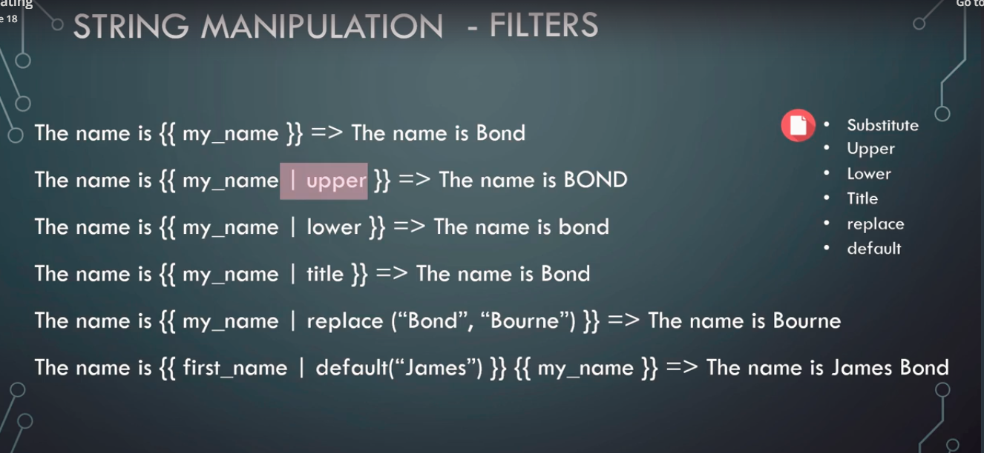

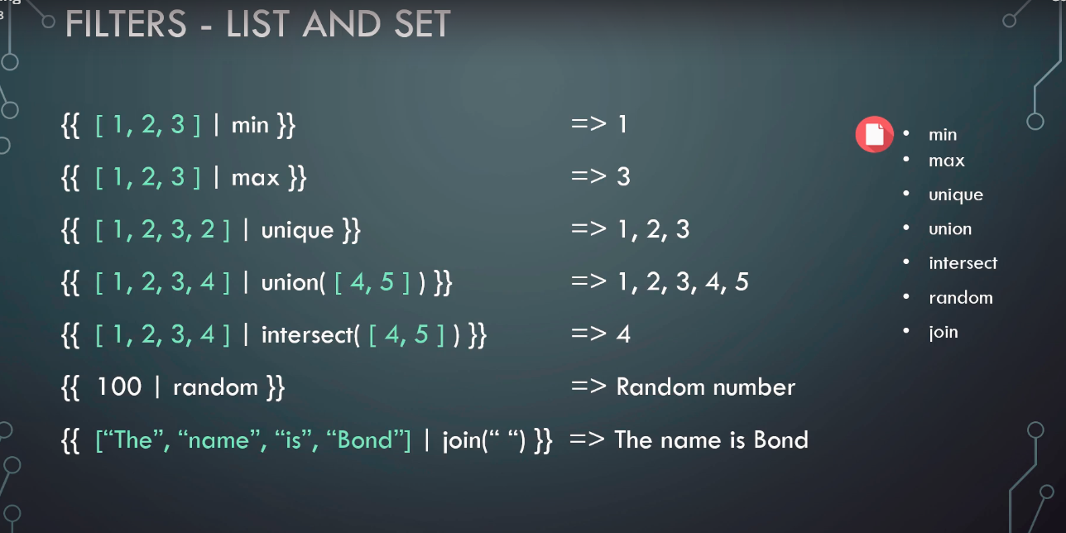

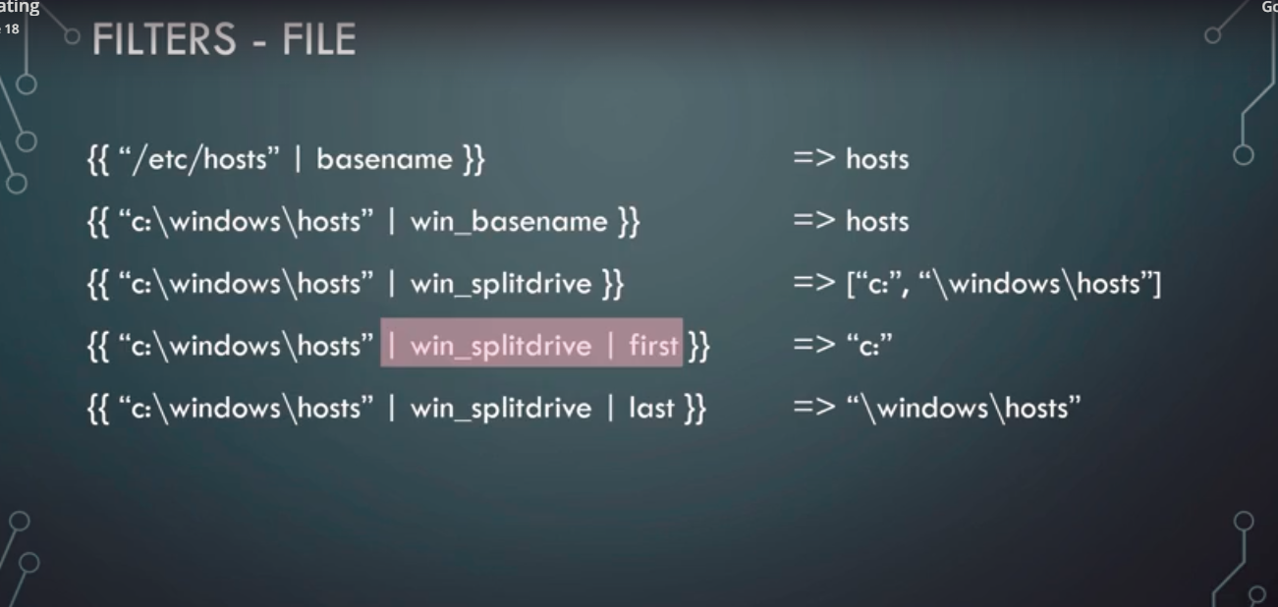

**LOOKUPS:**

* To fetch data from other files .
* For example, we have server hostname and password stored in the inventory files, if we have thousands of servers, then a good approach might be to store these credentials in csv file.
* Some available look up options are - csv, ini, DNS, mongodb

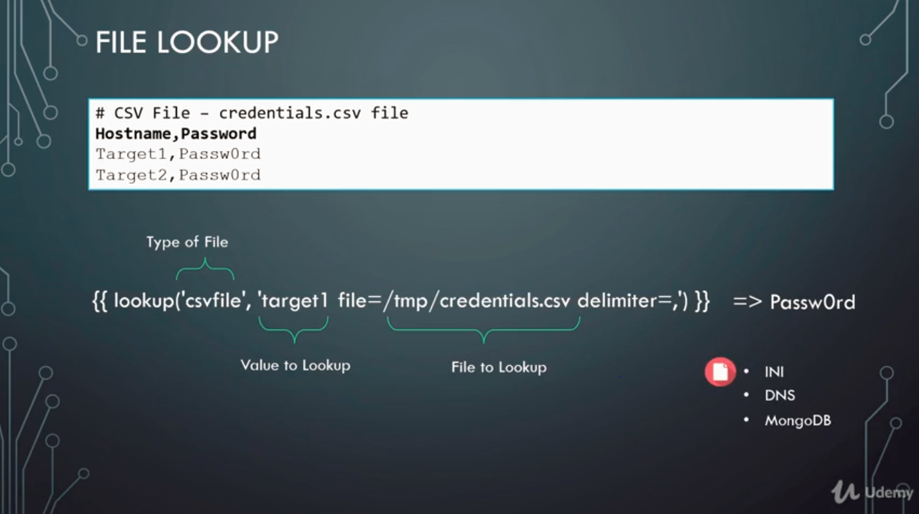

**Vault:**

* Helps to store sensitive data (server password) in an encrypted format.
* ansible-vault encrypt inventory.txt :

1. This command asks us to enter a new vault password.
2. On entering the command the file gets encrypted.

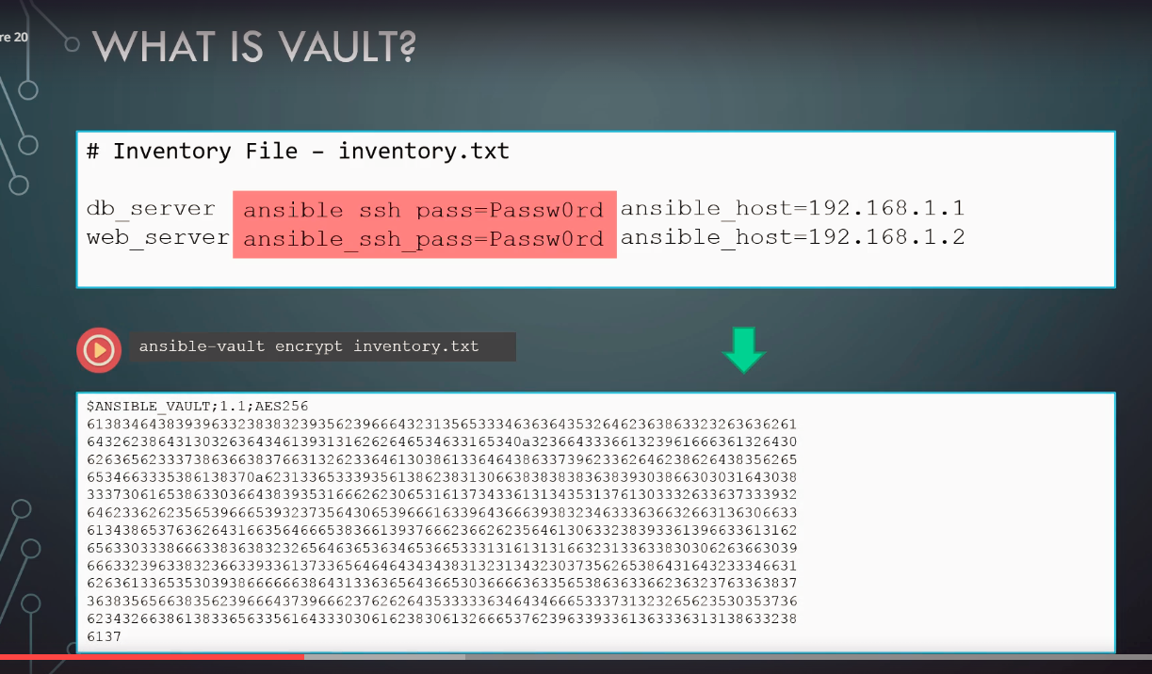

* If we are using any encrypted files in ansible, we must run the ansible-playbook command using '-ask-vault-pass' flag to enter the vault password. Else, ansible won't be able to use the encrypted files and return error.

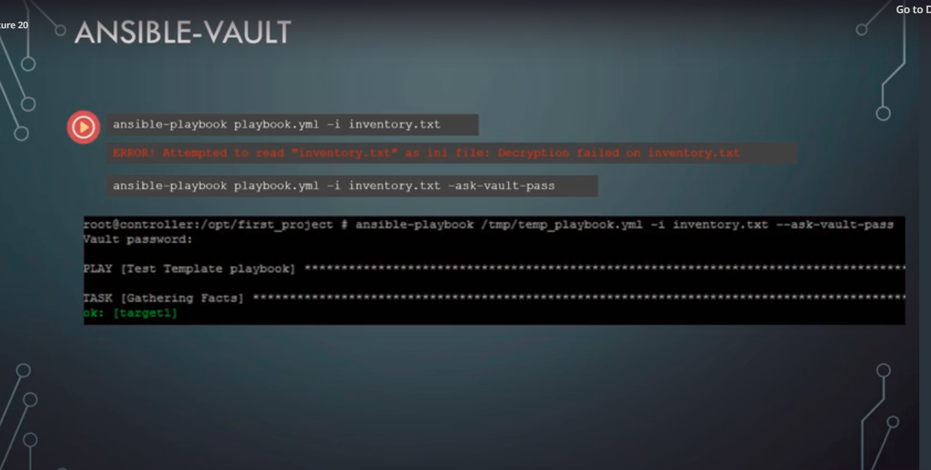

* Instead of prompting to type the vault password everytime, we can place the vault password in an different file, and have the file passed into the ansible-playbook command using ' -vault-password-file' flag.

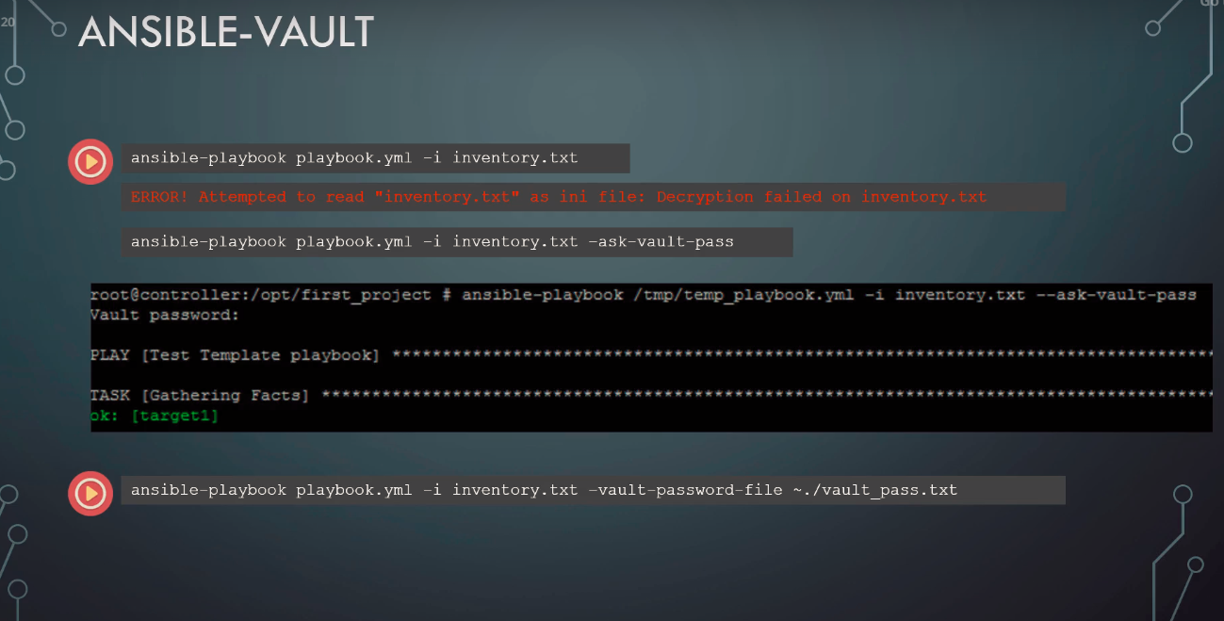

* But again the password will be stored in a plain text format in some file. So this option is also not good.
* Best option will be to put the vault password to a secure location and write some python file to retrieve the vault password.
* 

* ansible-vault -view <file_name> : this command is used to read the encrypted files names.
* Ansible-vault create inventory.file : creates a new encrypted file.

**DYNAMIC INVENTORY:**

* Most of the time we don't want to hardcode our servers in a static inventory file.
* We may want to fetch the details of the servers from the other source (say, a database or a cloud platform api) when the ansible play book is run
* ansible-playbook playbook.yml -i <python file>: command can be used to run playbook and fetch inventory details from the the script:

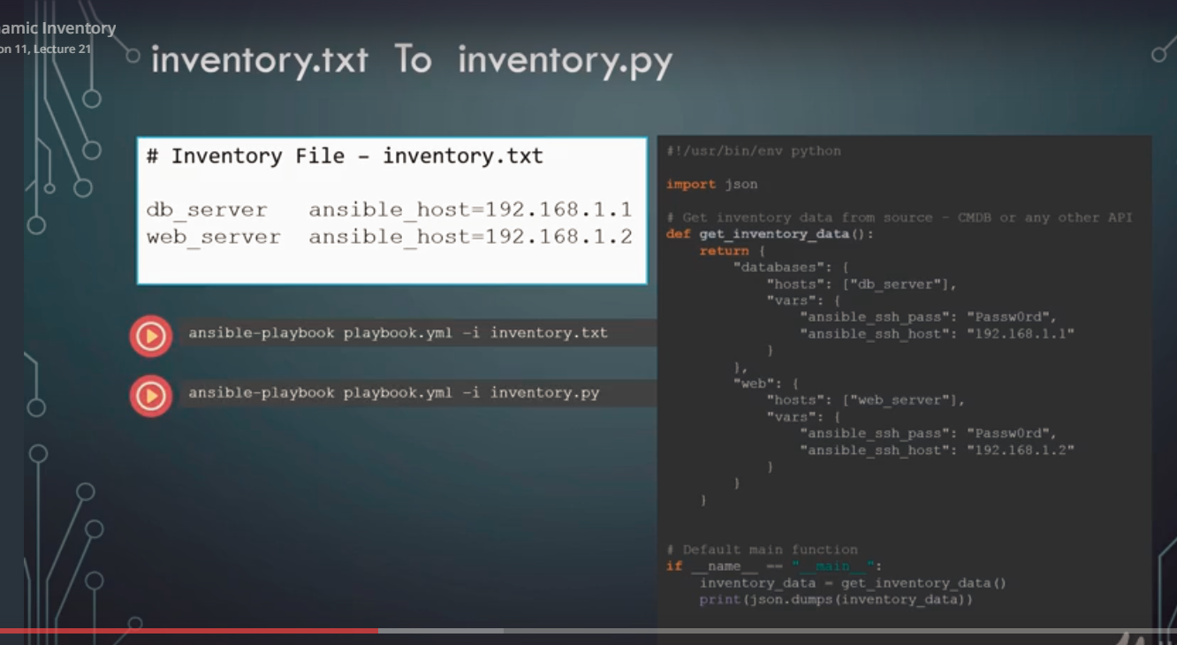

* The output of the inventory script will be used as the inventory information.
* We need to specify what environment we need to run the inventory script is in:

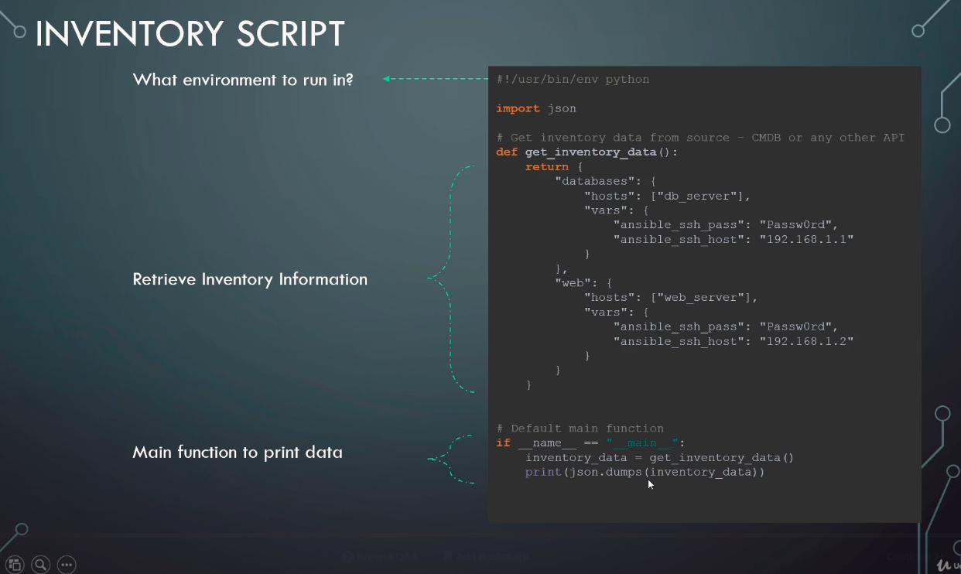

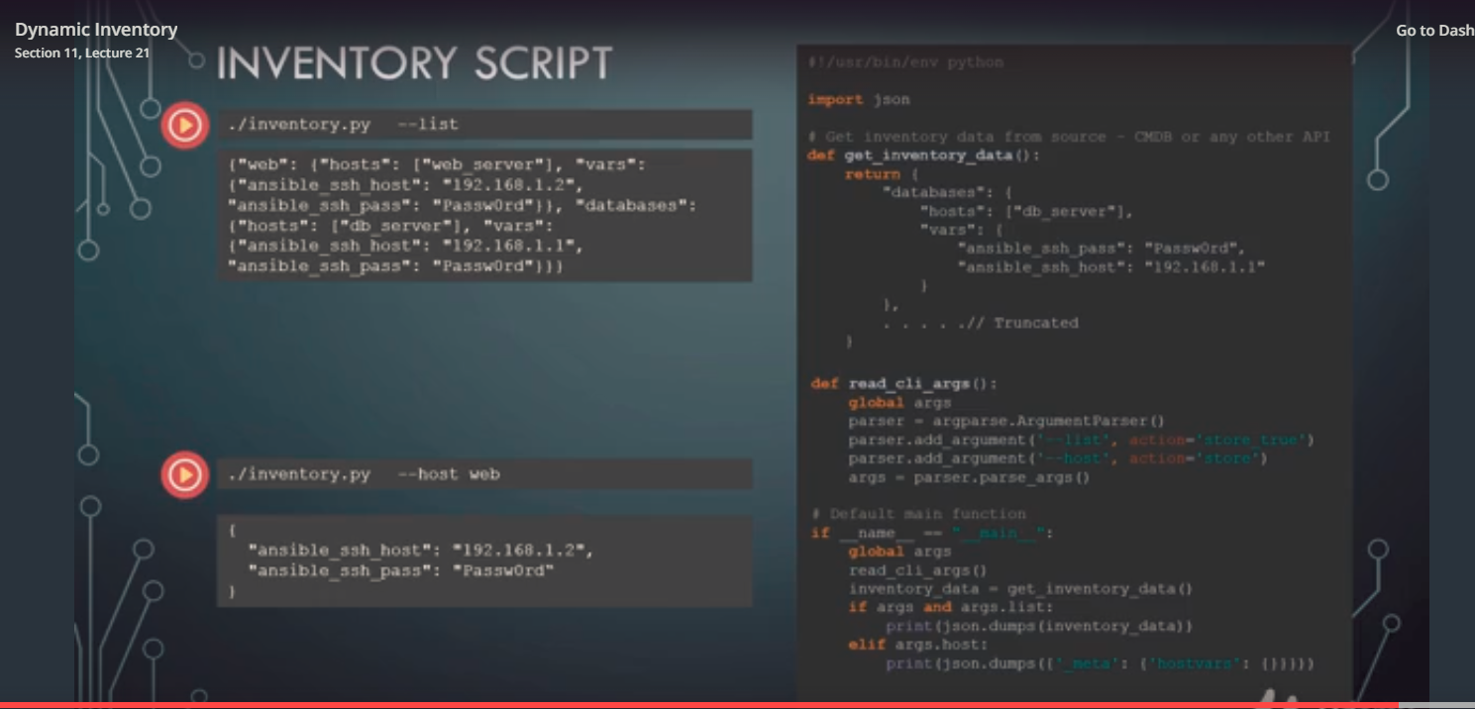

CUSTOME MODULES:

* Modules are basically python code.
* We can create our custom modules using python
* ansible-doc <module-name> will give the documentation of that module.

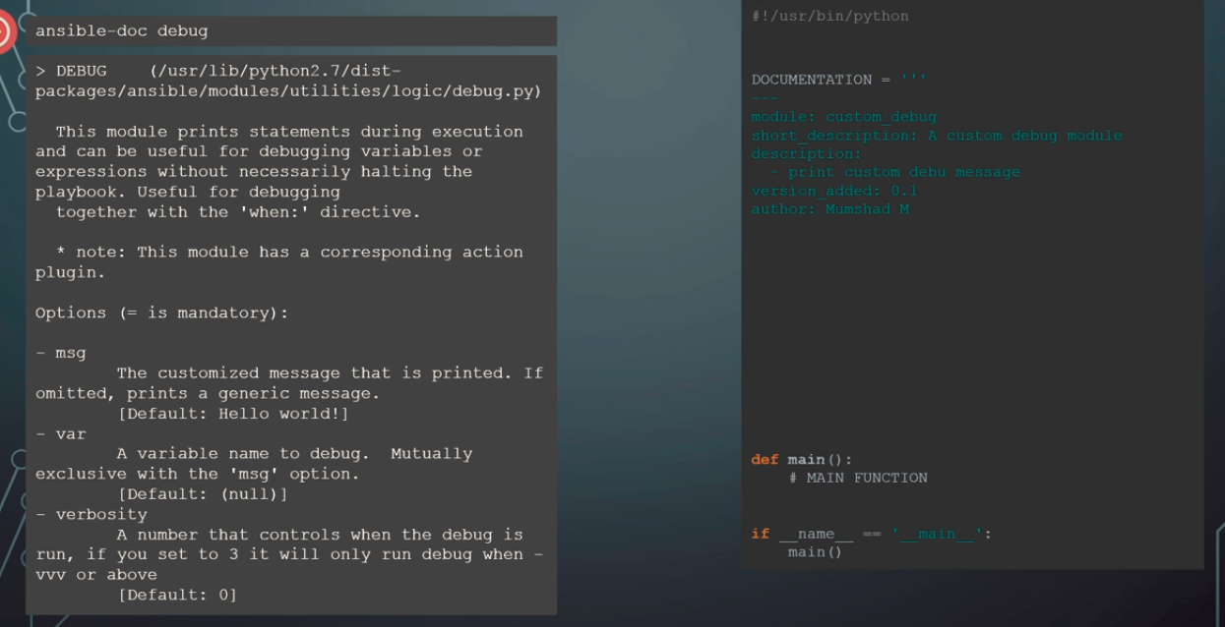

* It’s a good practice to provide the documentation when creating a custom module.
* We can provide the documentation in the 'documentation' block in the python code.
* We can also provide an example of how to use the module in the 'example' block of the python code.
* 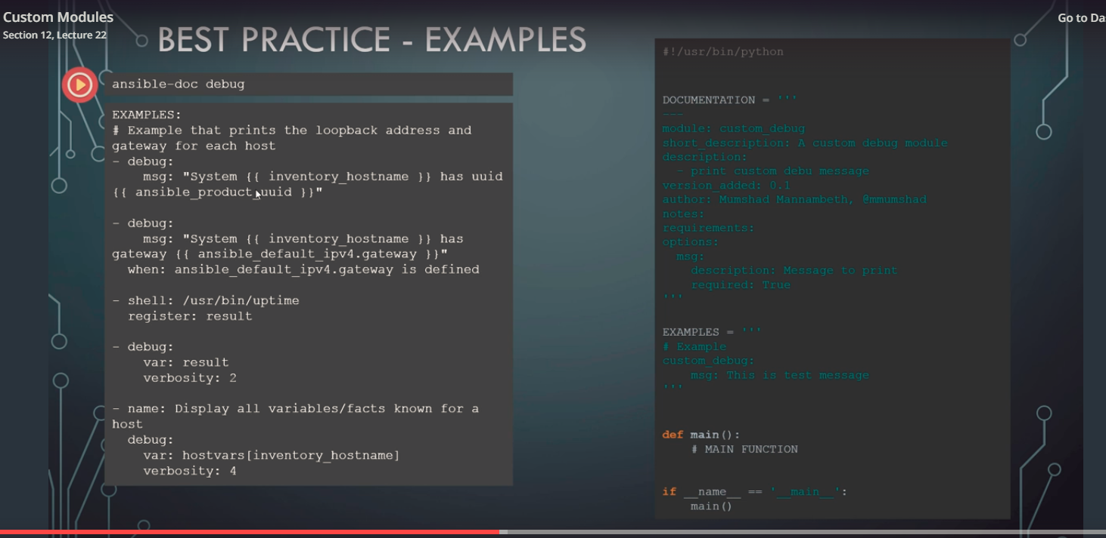

Where are these modules created ?

Plugins:

* Filter Plugins:

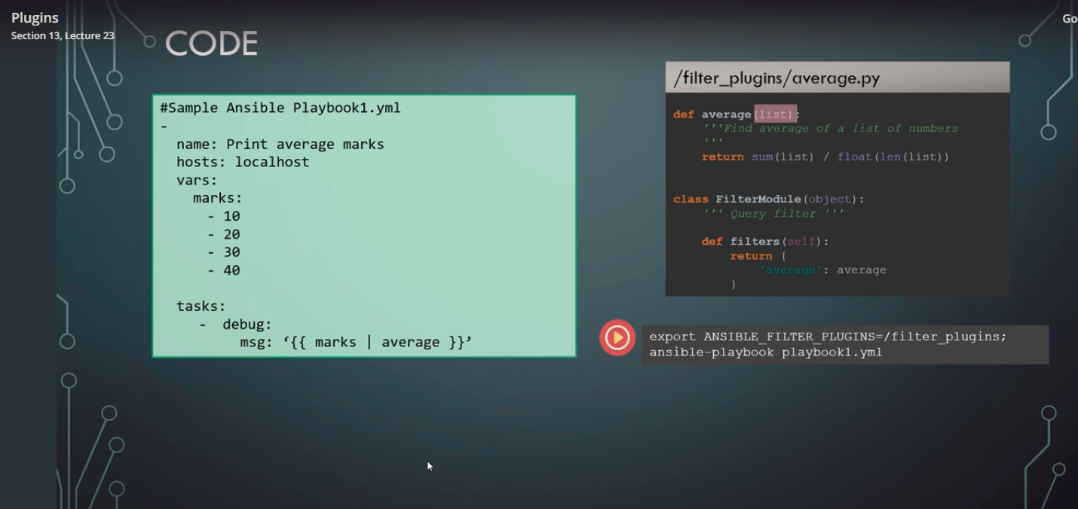

* Callback plugins:
* The output we see from callback is the result of the callback plugin
* The information we see on the console screen when running the ansible playbook is the result of the callback plugin.
* The default output of the ansible in the console is called skippy
* We can print execution result in json format as well using 'ANSIBLE_STDOUT_CALLBACK=json' option when running the code.

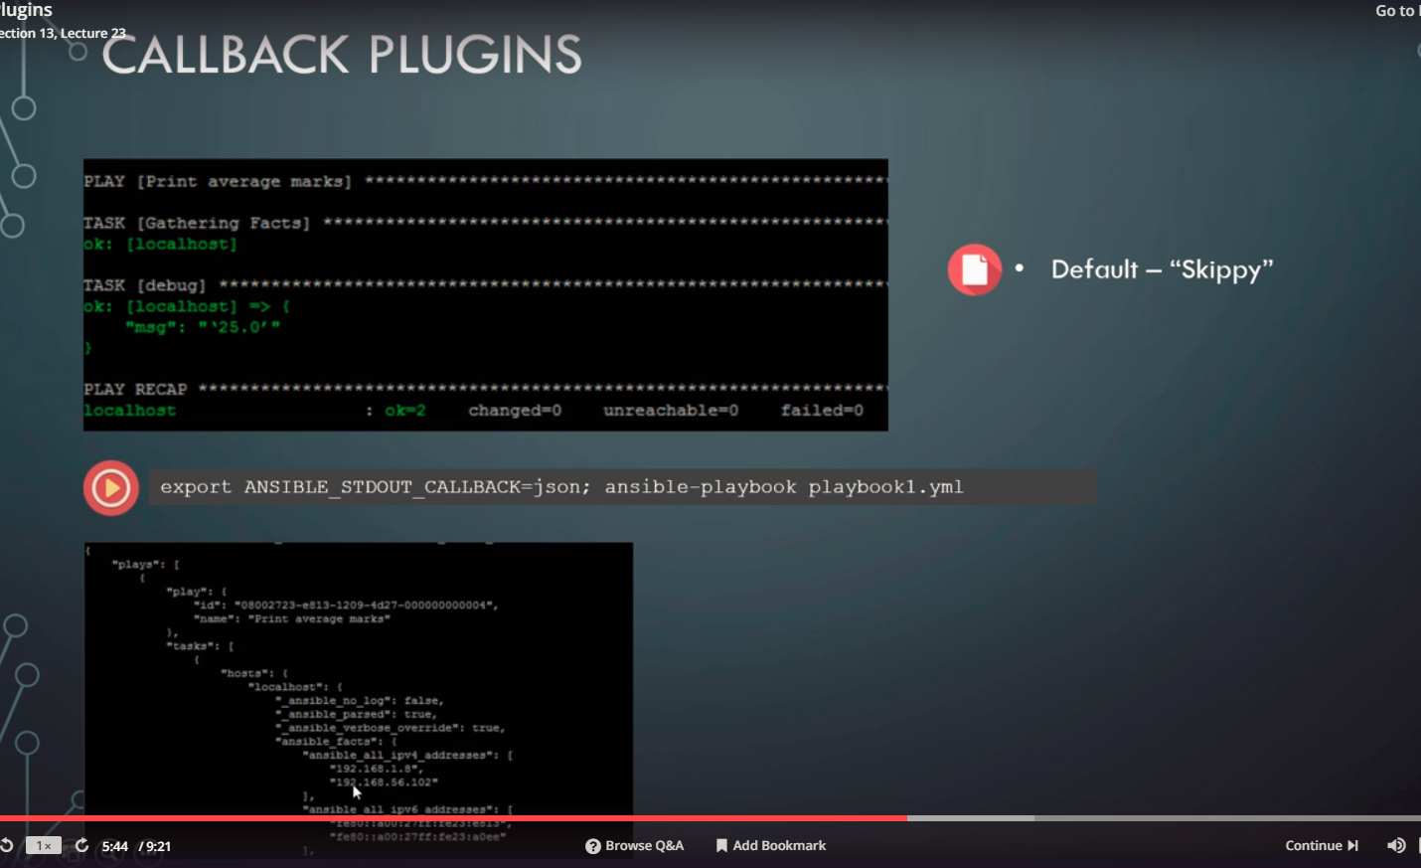

* Callback plugins have other use cases as well :

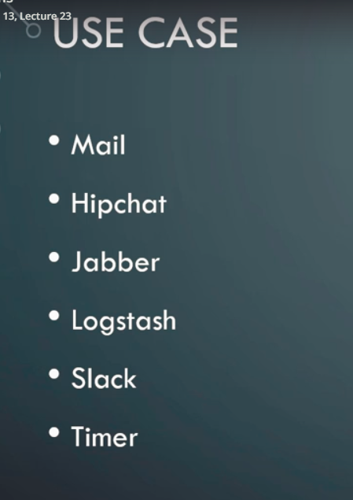

Important Concepts:

1. Ansible become directive:

* Ansible always logs to the target ssh server as remote_user
* If we use 'become: yes', ansible calls sudo or other escalation tools to run the command as become user.
* Become: yes' activates privilege activation.
* 'Root' is the default user for privilege escalation. Below task will be executed as root.

- do: something  
 become: yes

1. Ansible become_user directive:

* The explicitly activate the escalation privilege to some user (another than default Root) we can use 'become_user : someuser'

- do: something  
 become: yes  
 become_user: someone>

* We need to use 'become' before using 'become_user' as default value of 'become' is no.

Modules:

1. Pause:

* Pauses a playbook execution until a set amount of time or until a prompt is acknowledged.

*# Pause for 5 minutes to build app cache.*  
- pause:  
 minutes: 5

*# Pause until you can verify updates to an application were successful.*  
- pause:

*# A helpful reminder of what to look out for post-update.*  
- pause:  
 prompt: "Make sure org.foo.FooOverload exception is not present"

*# Pause to get some sensitive input.*  
- pause:  
 prompt: "Enter a secret"  
 echo: no